

User Manual
Employee Self Service
www.flowhcm.com



Attendance Module

Attendance Request
- To add attendance request, click on Add New Request
- Select employee and Attendance date
- Enter In & Out time, select attendance type and enter reason for request
- Click on submit button to raise a requisition

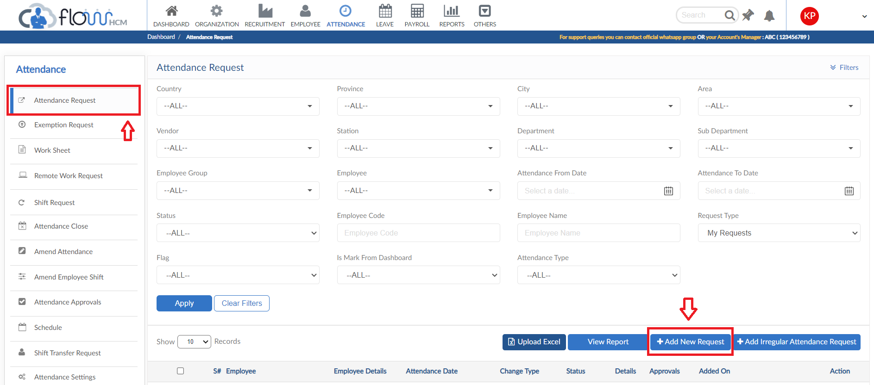
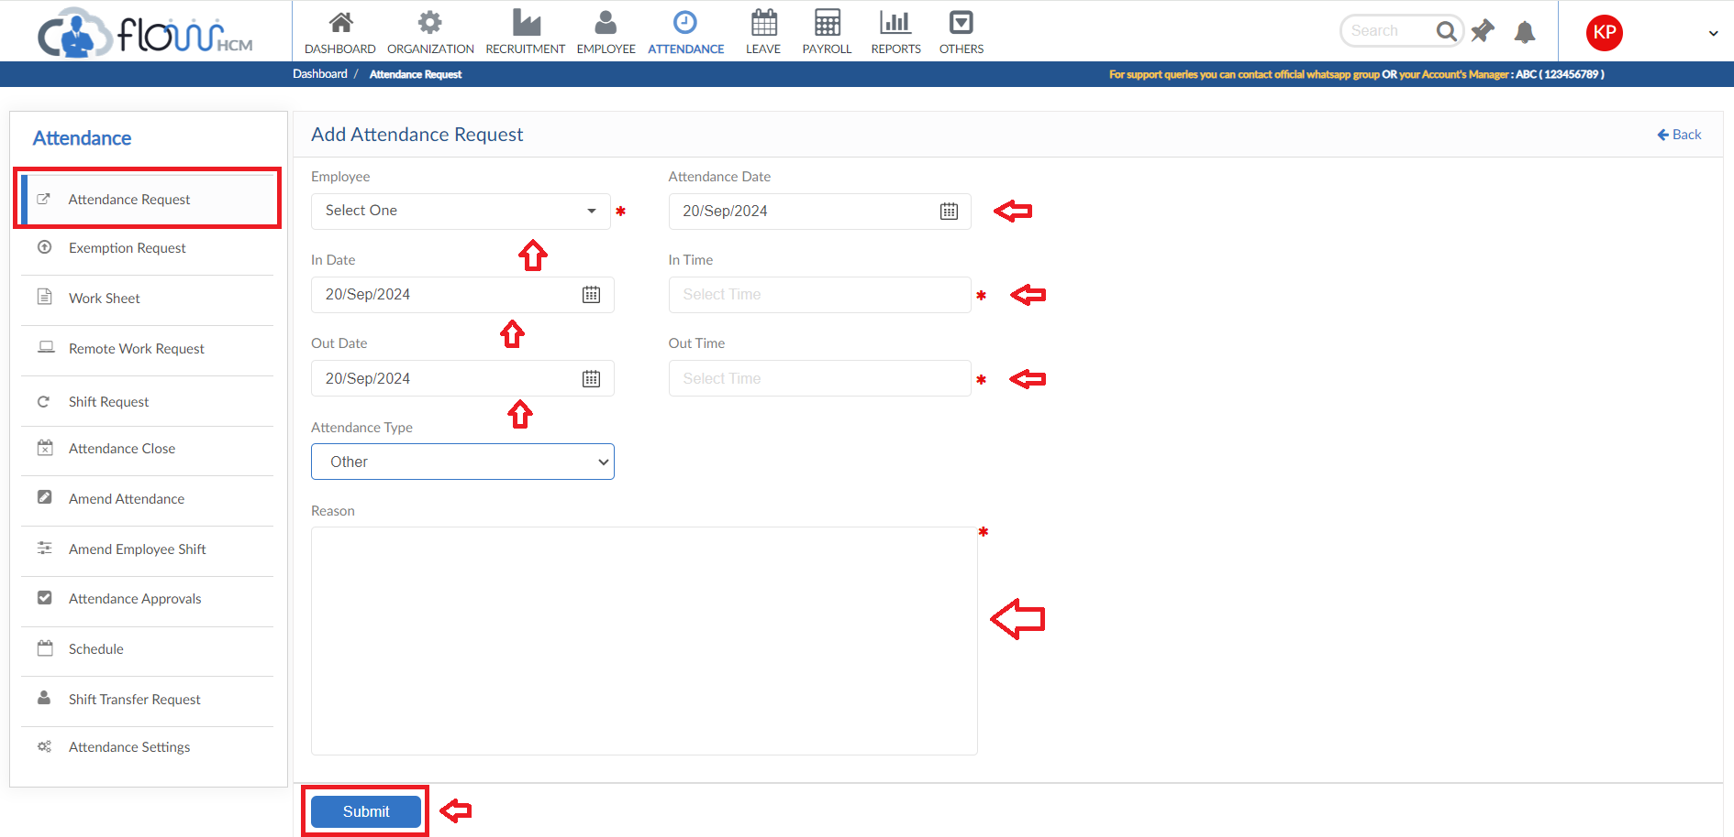

Irregular Attendance Request
- To add Irregular Attendance Request, click on Add Irregular Attendance Request
- Select the date range and attendance type, click on Apply to populate the grid
- Select the required row and enter data as per need
- Then click on submit button to raise a request

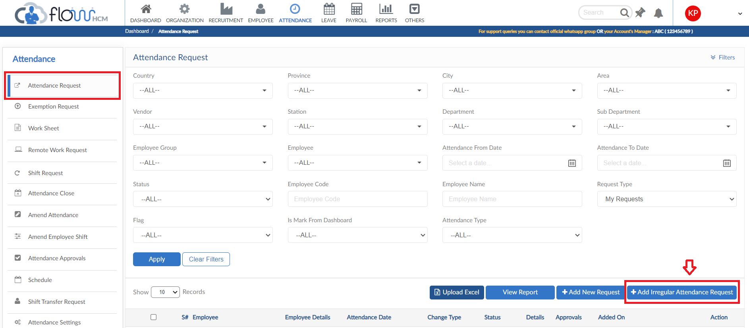
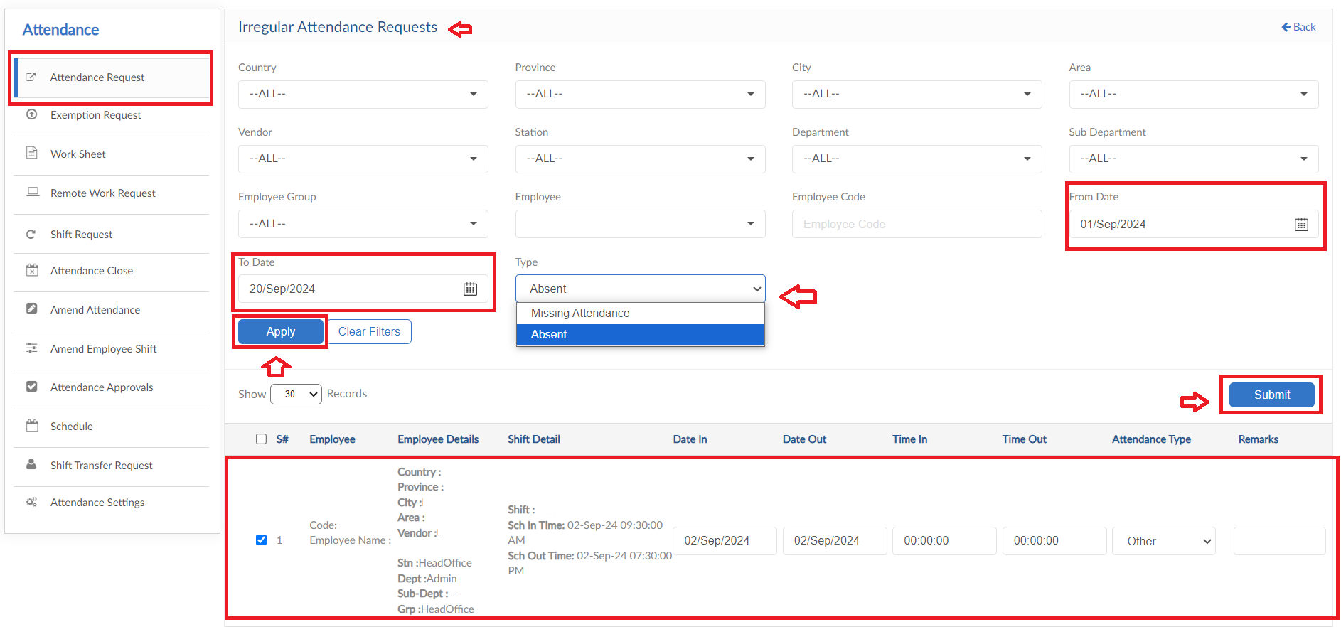

View Report
- To view the data of grid in Attendance Request form click on view report
- Attendance Request Report will pop up on screen

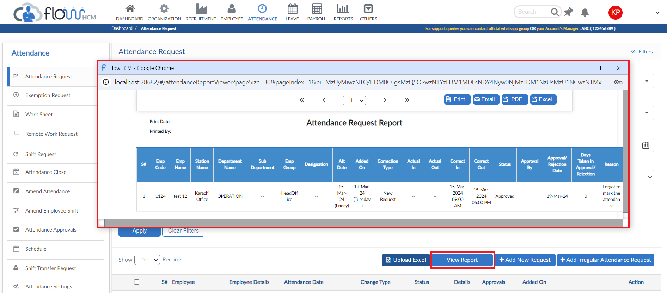

Exemption Request
- To add an Exemption Request, click on Add New Request
- Select an employee and date for Exemption
- Flag type will be visible automatically by system
- Select Exemption Type and enter Reason for request
- Then click on submit to raise a requisition

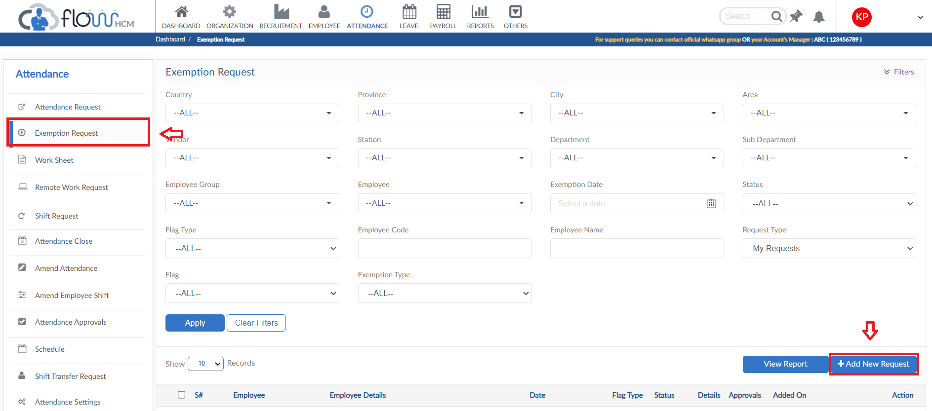
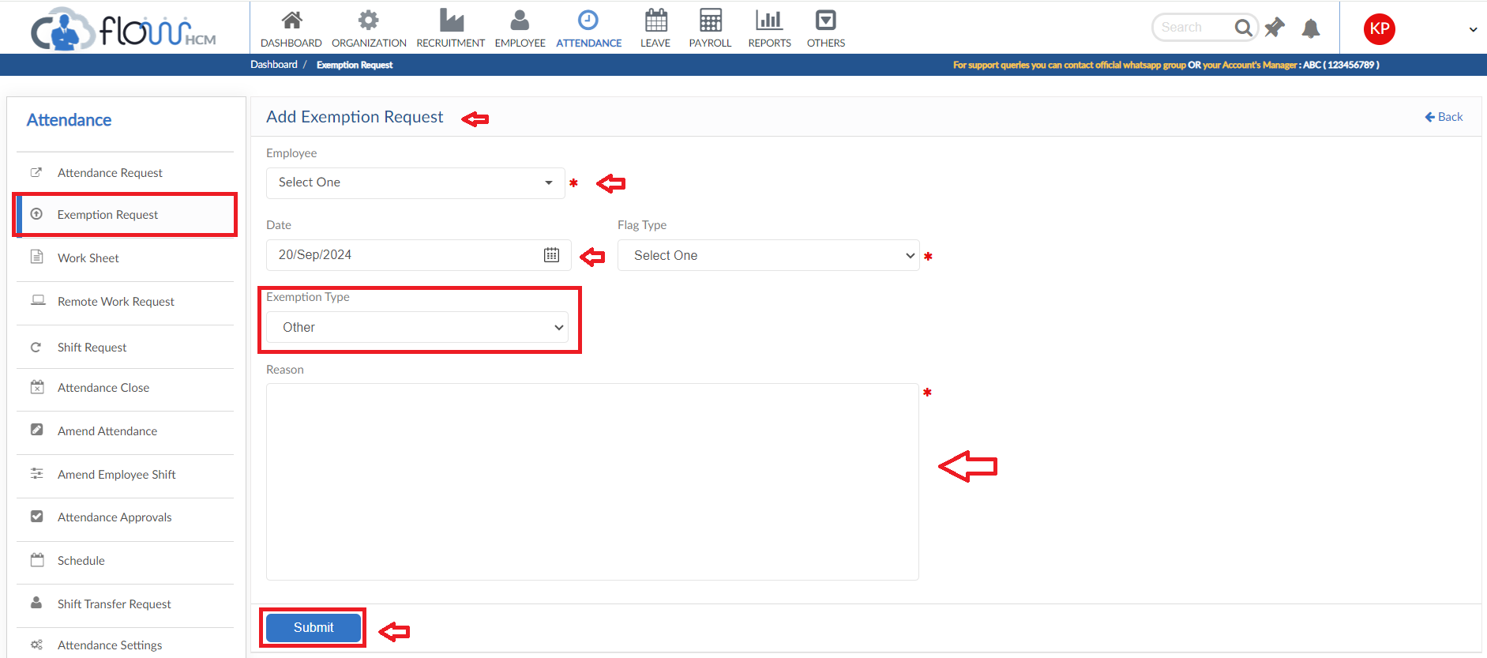

View Report
- To view the data of grid in Exemption Request form click on view report
- Exemption Request Report will pop up on screen

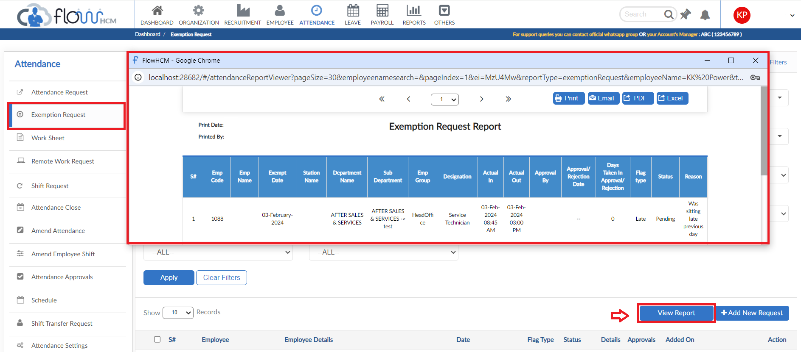

Worksheet
- To add a Worksheet, click on Add New Worksheet
- Select an employee and date for Worksheet
- Enter title of Worksheet
- Select Project form dropdown, Start & End date will be fetched from Worksheet date
- Enter Start and End time of the work done
- Enter description for Worksheet Request
- Then click on submit to raise a requisition

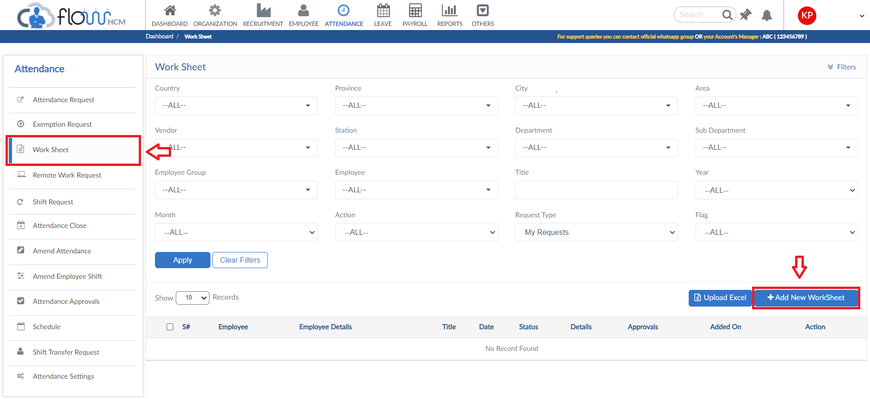
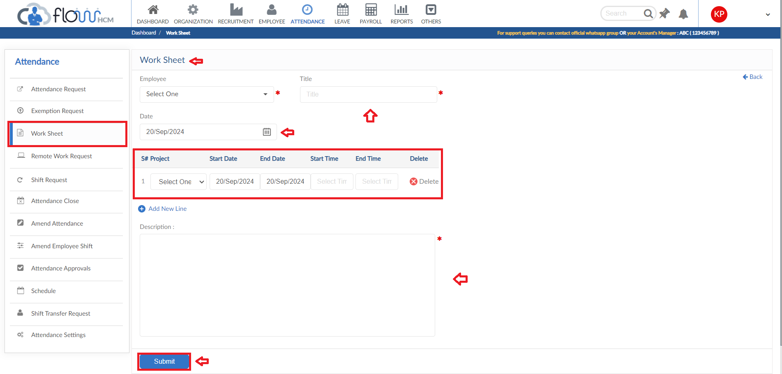

Remote Work Request
- To add a Remote Work Request, click on Add New Request
- Select an employee and date for Remote Work
- Enter In & Out date and Time In & Out for Remote Work Request
- Enter a reason for requisition
- User can also upload an attachment if required
- Then click on submit to raise a requisition

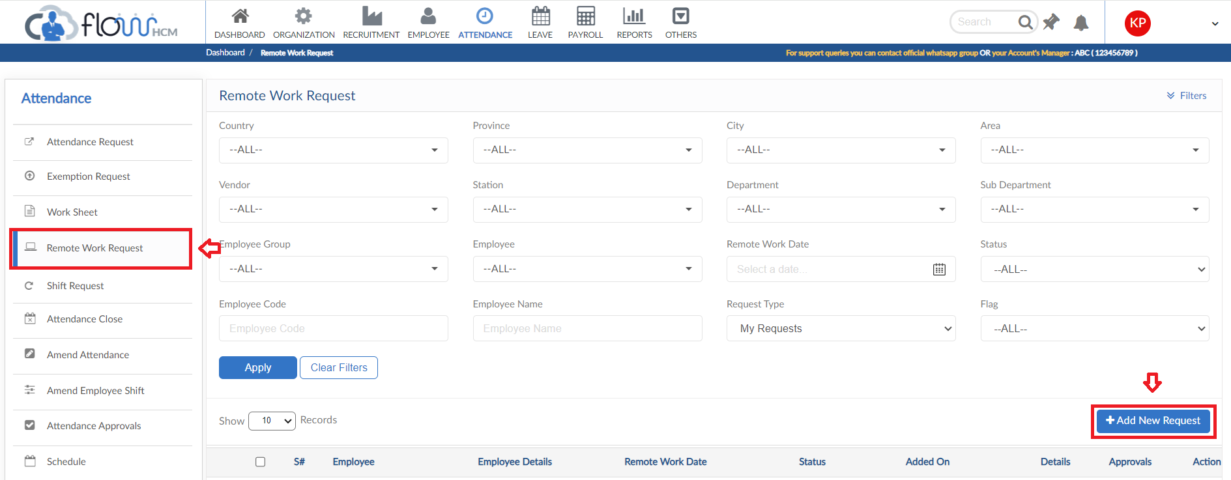
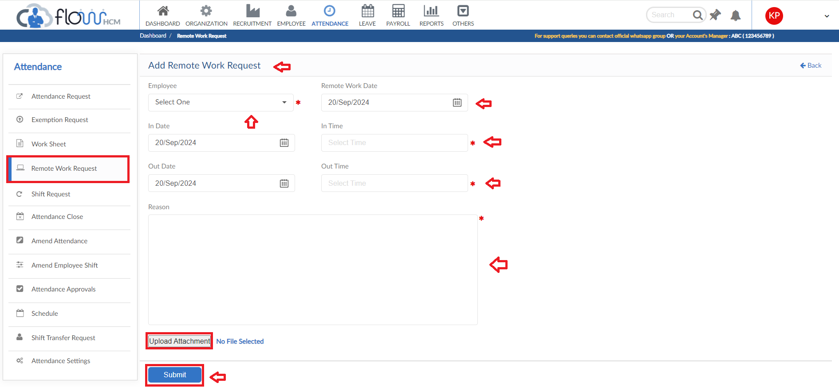

Shift Request
- To add a Shift Request, click on Add New Request
- Select an employee and date for Shift Request
- System will automatically show the Current shift of employee
- Select the Desired Shift from dropdown
- Enter a reason for Shift Request
- Then click on submit to raise a requisition

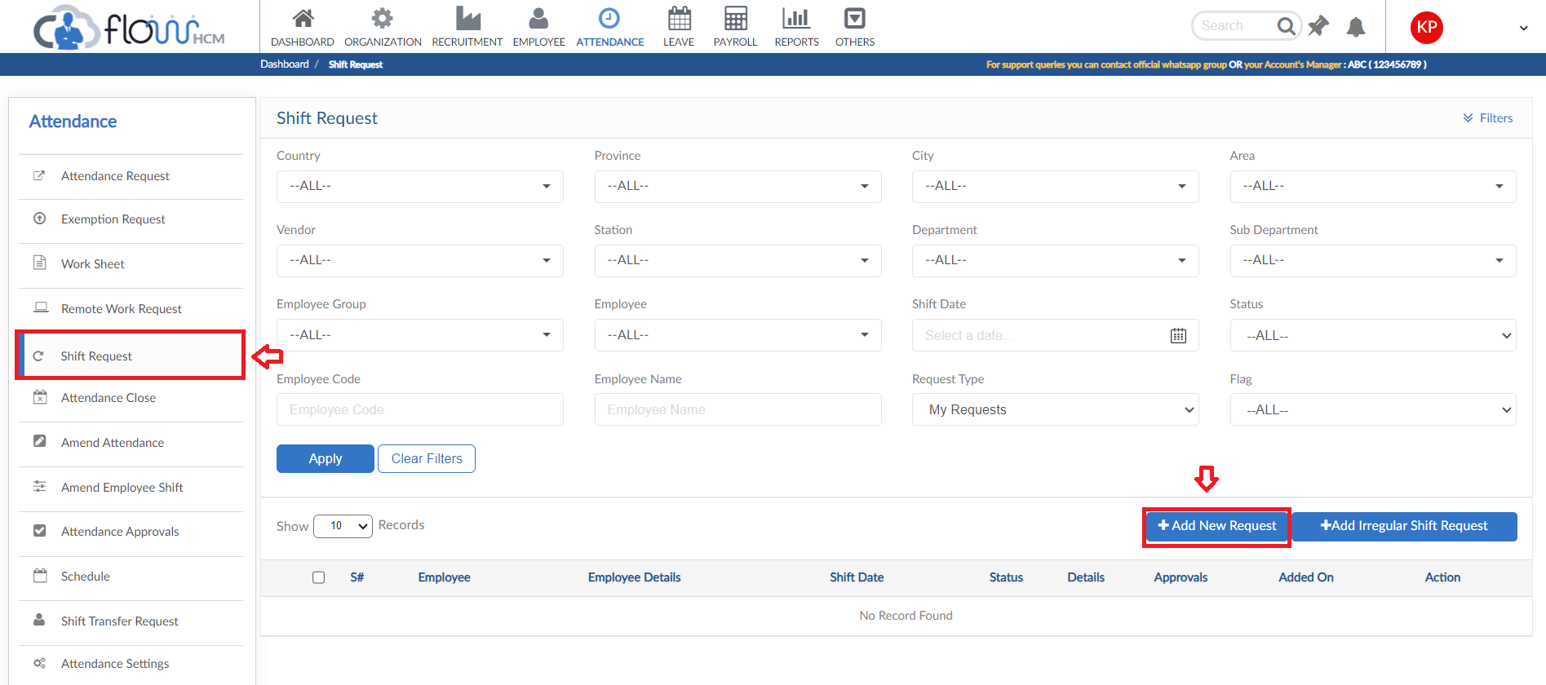
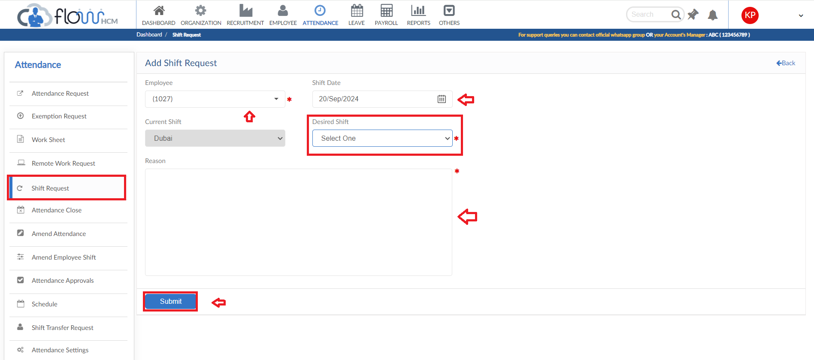

Leave Module

Leave Request
- To add Leave request, click on Apply for Leave
- Select employee and Leave Type
- Enter leave duration from dropdown, then enter date range
- System will automatically generate Leave days
- Enter a reason for request
- Employee Leave Summary will be shown on top right
- User can attach a file also if required
- Click on submit button to raise a requisition

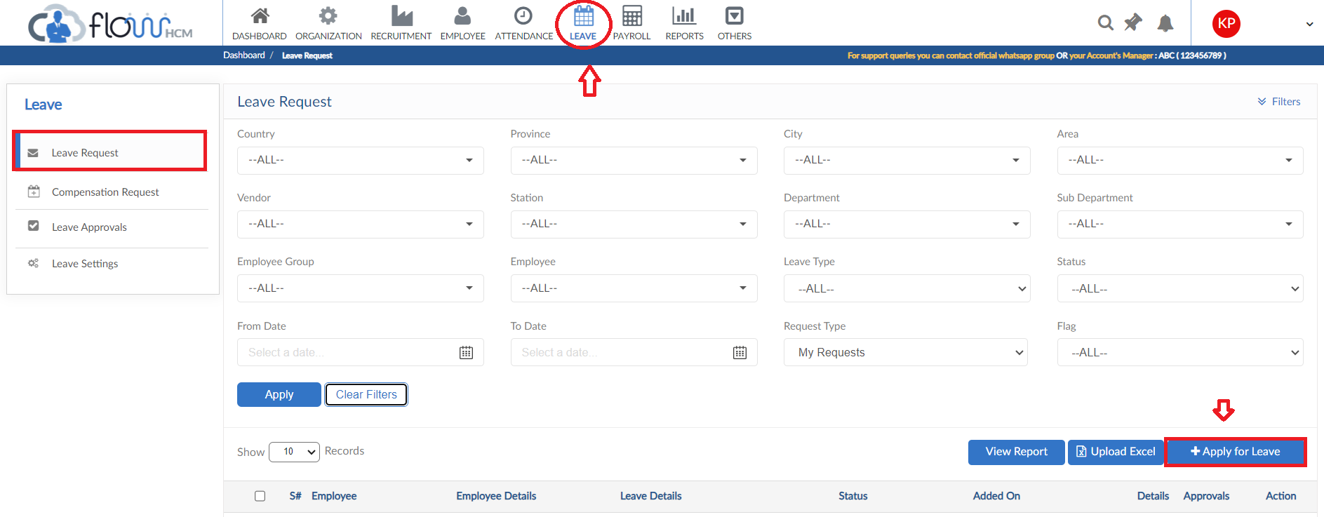
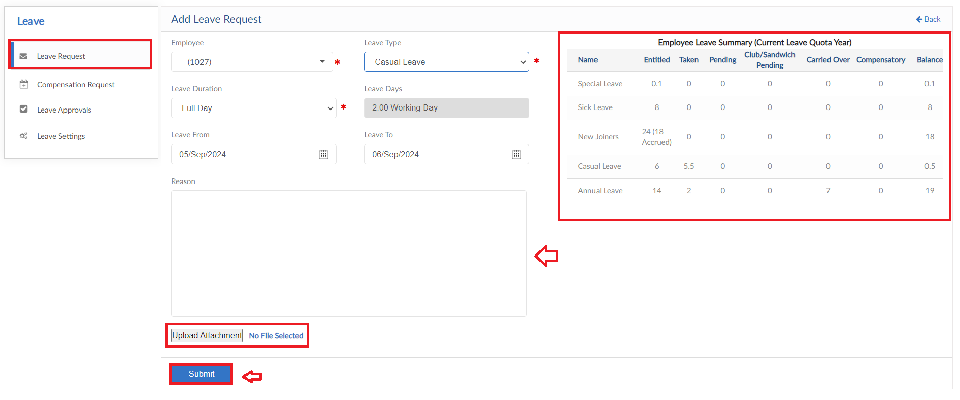

Compensation Request
- To add a Compensation Request, click on Compensation Request form
- The form consists of multiple request buttons

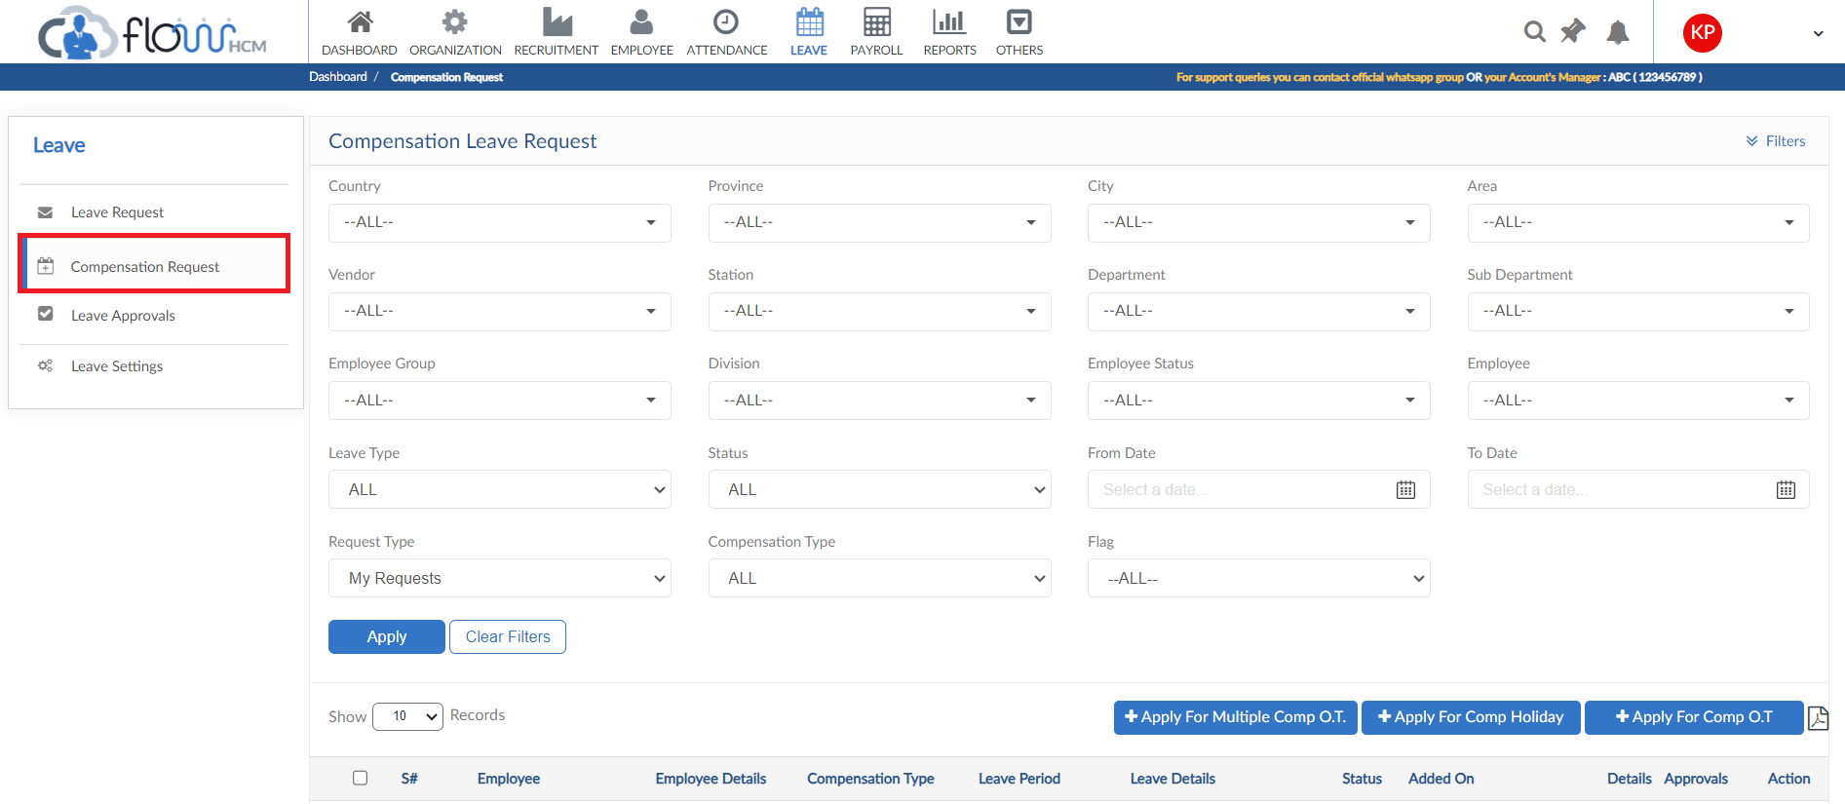

Compensation for Overtime
- Click on Apply for Compensation O.T
- Select the required Employee and Leave Type from dropdown
- Select the Month and Year from dropdown
- System will automatically generate OT & Compensated OT hours
- Enter a reason for request then click on Submit button

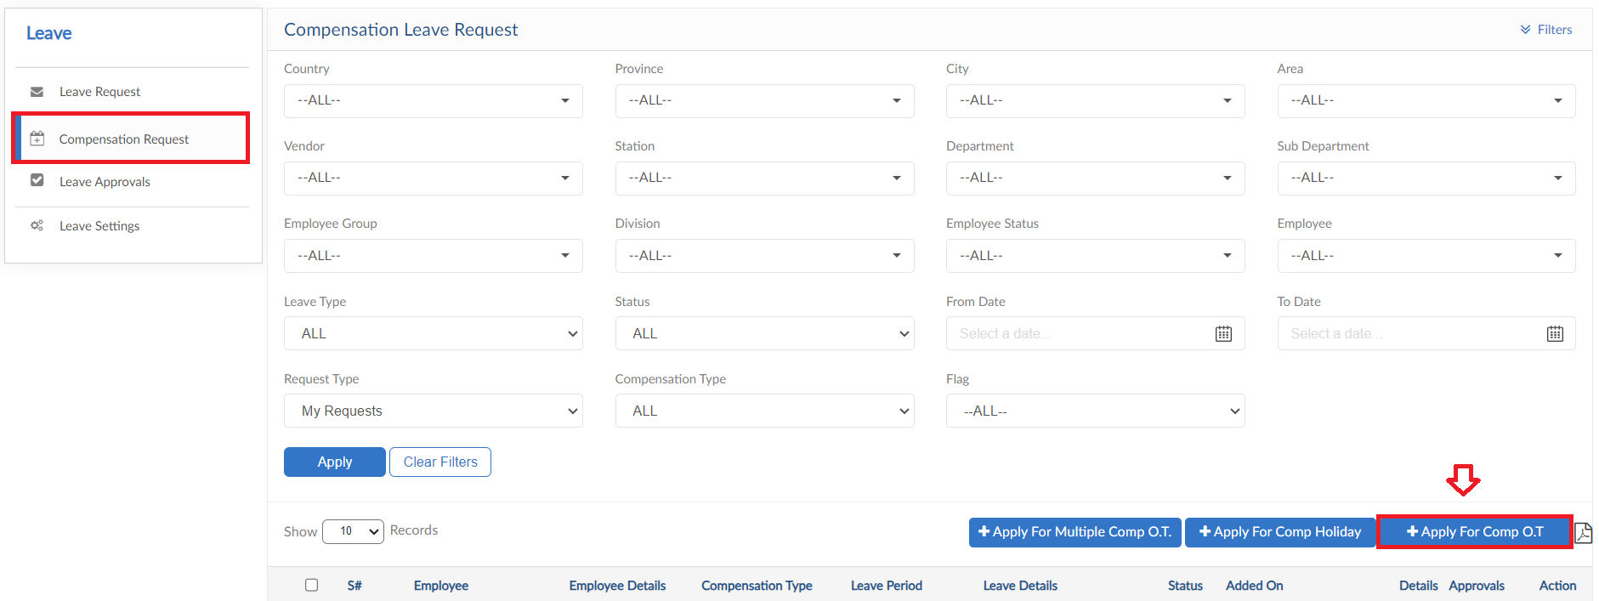
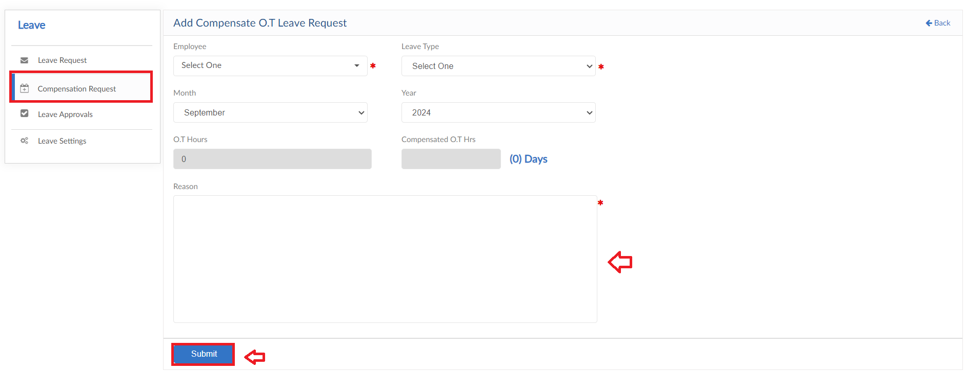

Compensation for Multiple Overtime
- Click on Apply for Multiple Compensation O.T
- Select the required Employee and date range then click on Apply button
- Mark the required rows, overtime details will be visible on grid
- Select the Leave type from dropdown and enter Leave days
- Enter a reason for request then click on Submit button

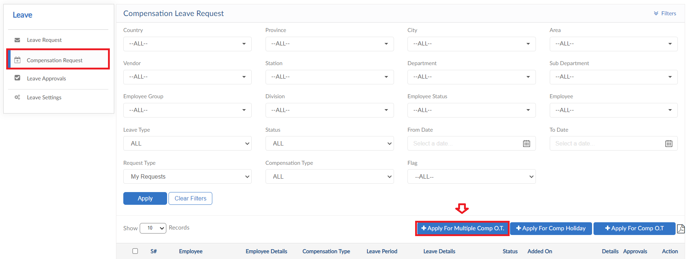
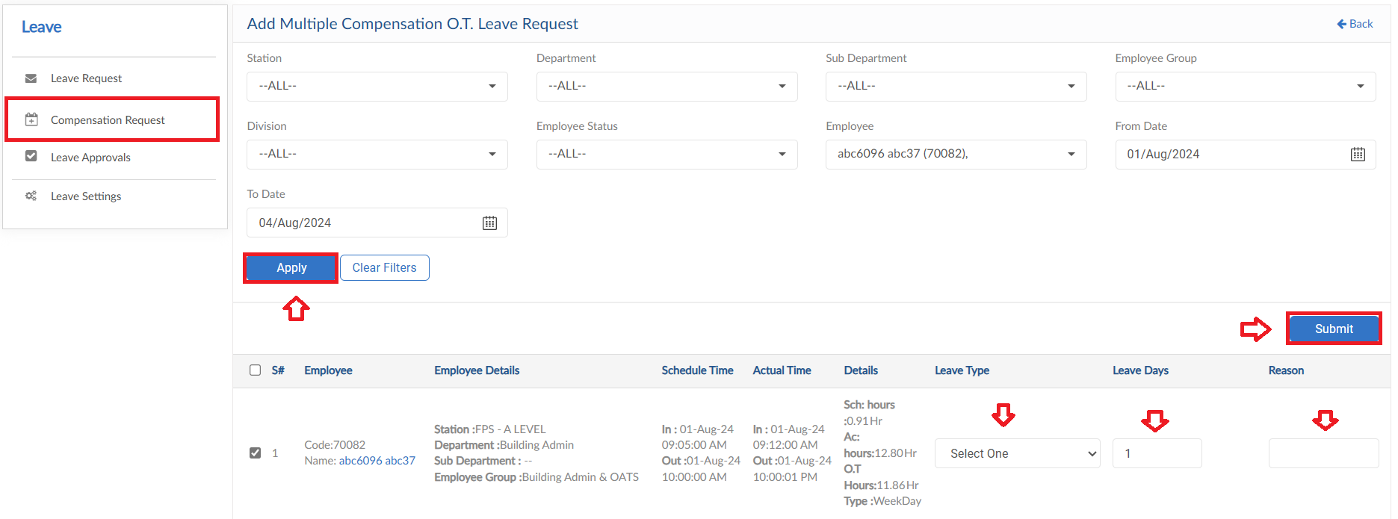

Compensation for Holiday
- Click on Apply for Compensation Holiday
- Select the required Station & Employee from dropdown
- Select the Leave Type and Leave Duration from dropdown
- Select the Leave type from dropdown and enter Leave days
- Select the date range for Leaves
- System will automatically generate Leave days
- Enter a reason for request then click on Submit button

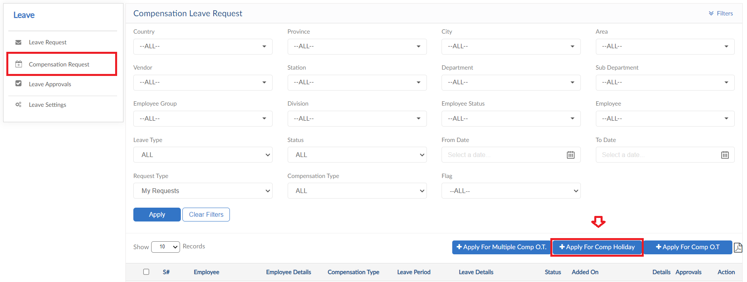
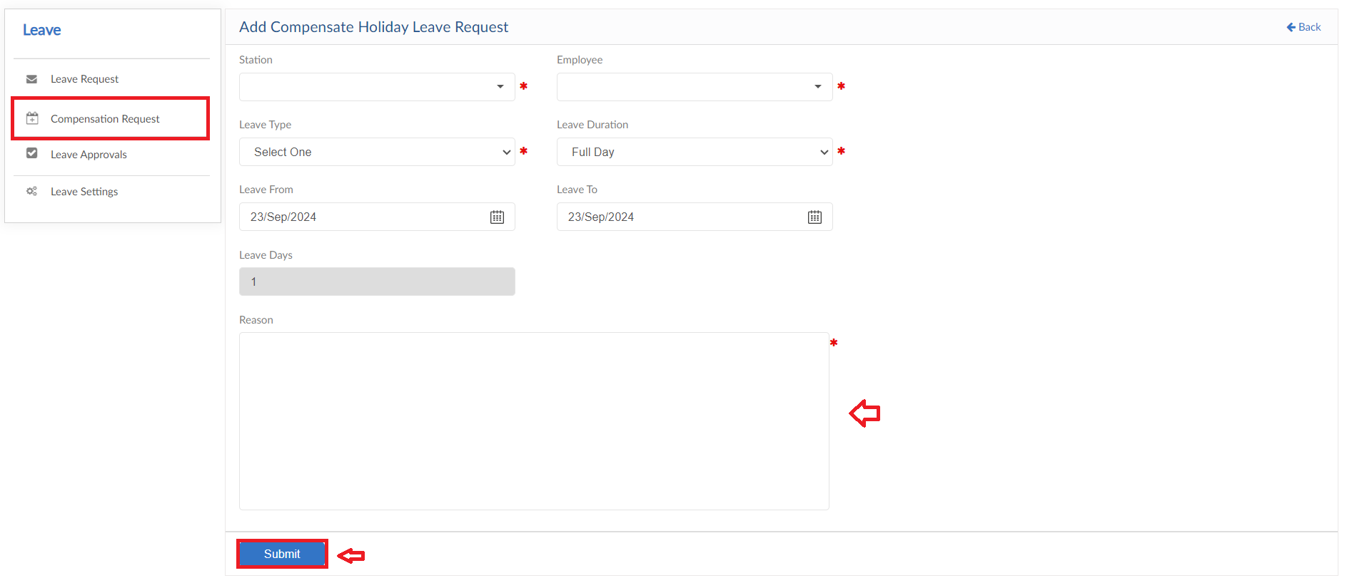

Payroll Module

Advance Salary Request
- To add an Advance Salary Request, click on Apply for Advance salary button
- Select an employee and enter tile for request
- System will automatically show history of Advance Salary requests of the selected employee
- Select a date and enter amount of advance salary required
- Enter a reason
- Then click on submit to raise a requisition

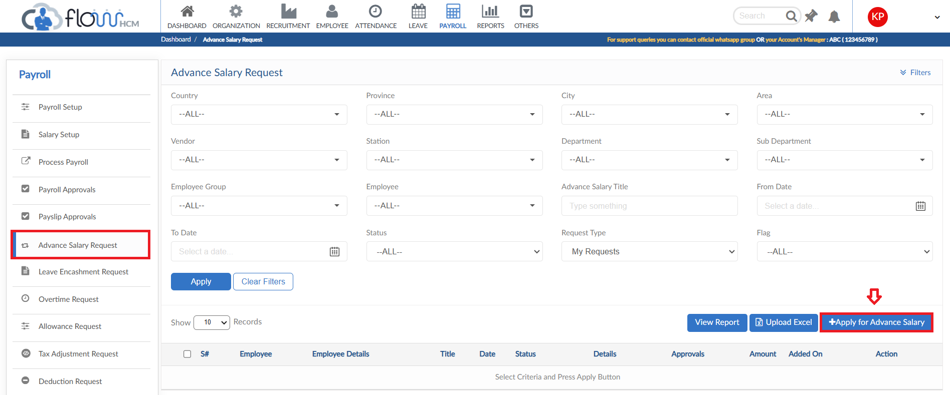
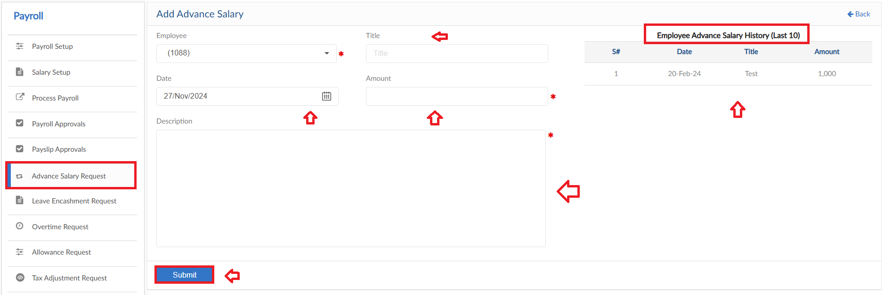

View Report
- To view the data of grid in Advance Salary Request form click on view report
- Advance Salary Report will pop up on screen

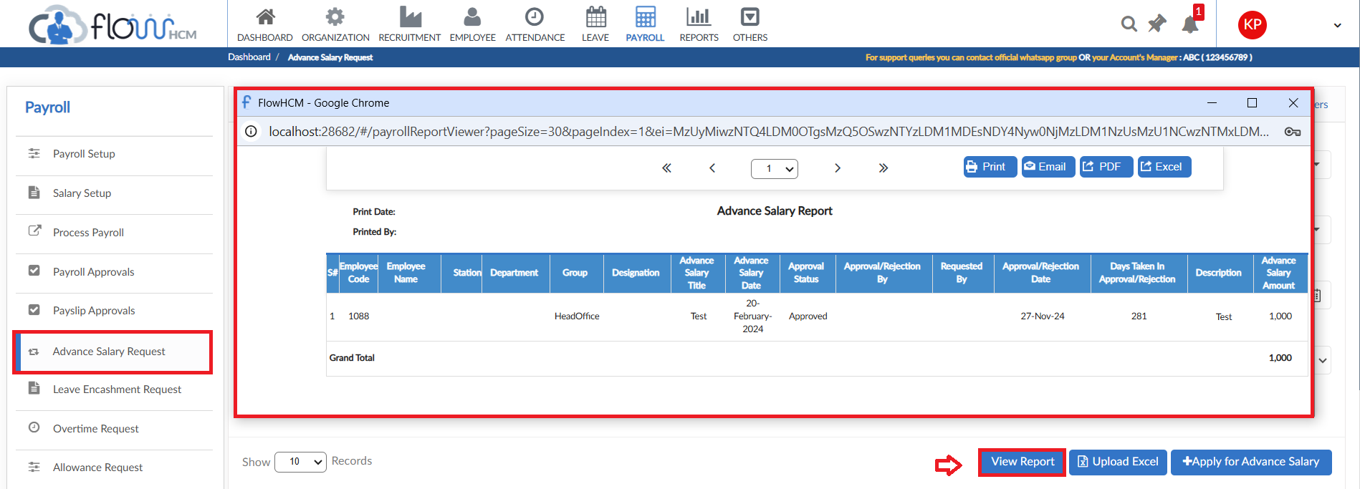

Overtime Request
The form consists of multiple buttons/features
- To add an Overtime Request, click on Apply for overtime in Overtime Request form
- Select an employee and enter Title
- Select date that will enable the desired overtime type field to enter hours
- Enter a reason for Overtime Request
- Then click on submit to raise a requisition

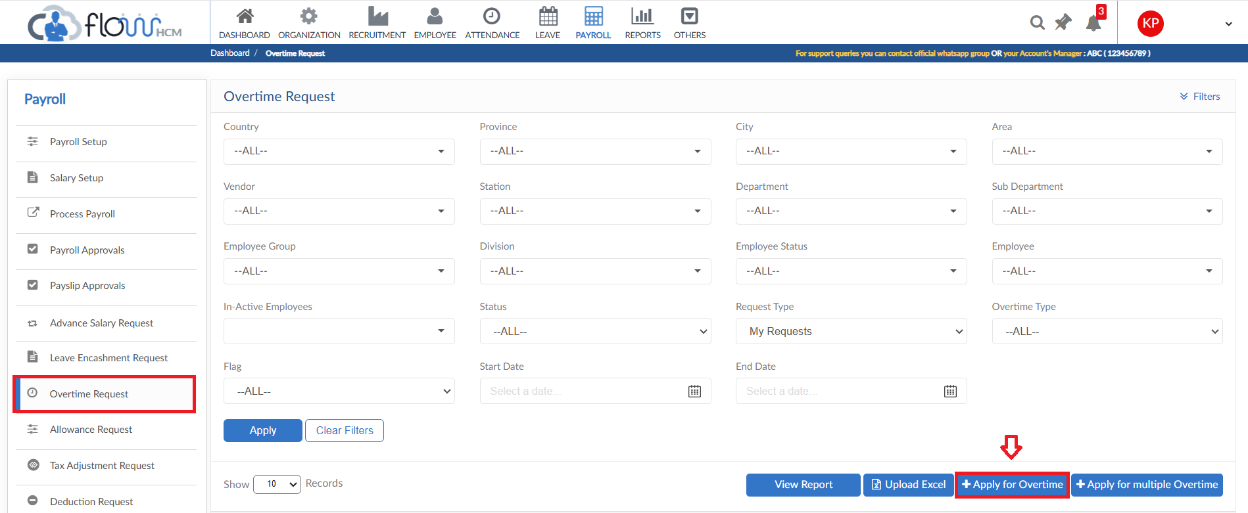
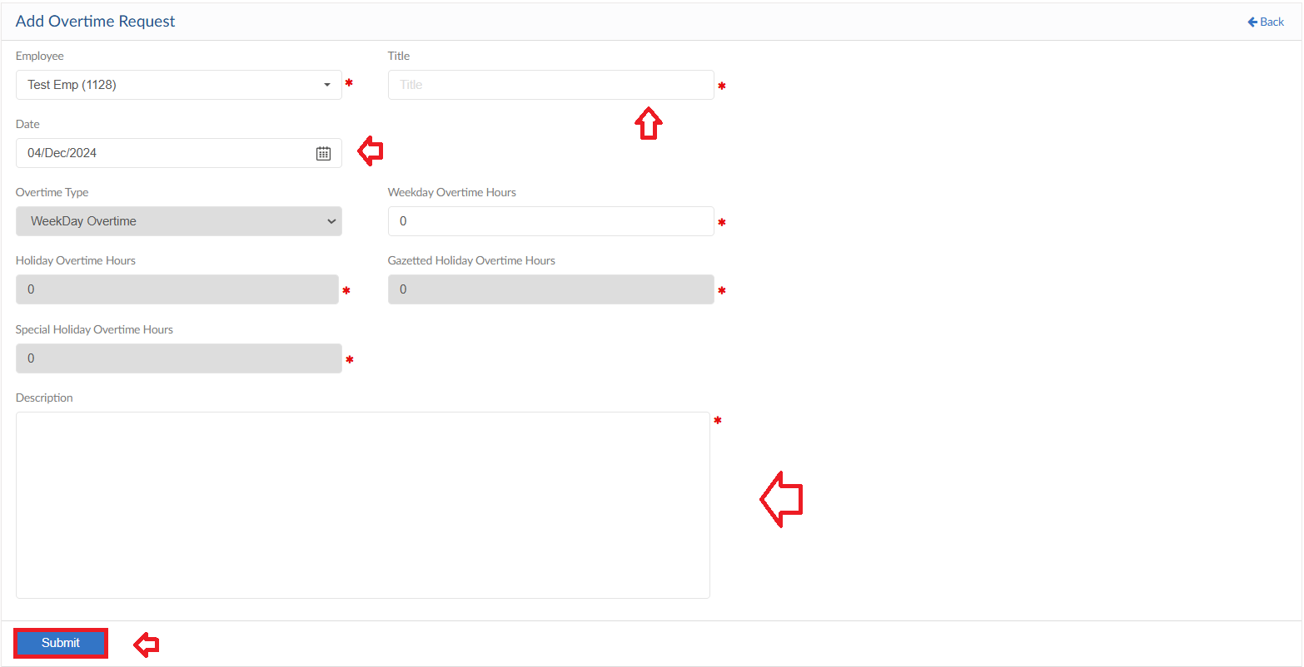

Multiple Overtime Request
- To add Multiple Overtime Requests, click on Apply for multiple overtime
- Select the filter criteria and then click on apply button
- System will list down the data according to the criteria selected
- Edit the hours if required else system will show the hours according to the policy
- Select a reason for every Request and enter Remarks
- Then click on submit to raise a requisition

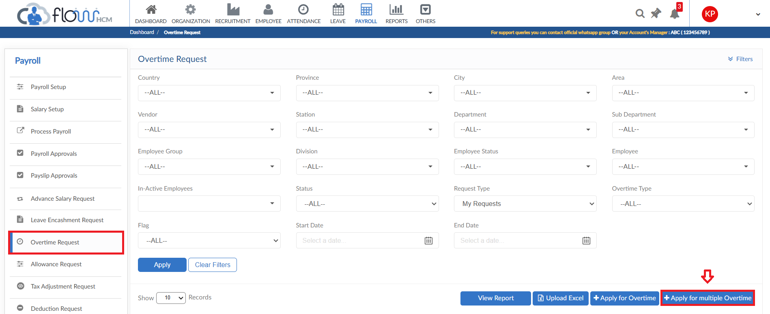
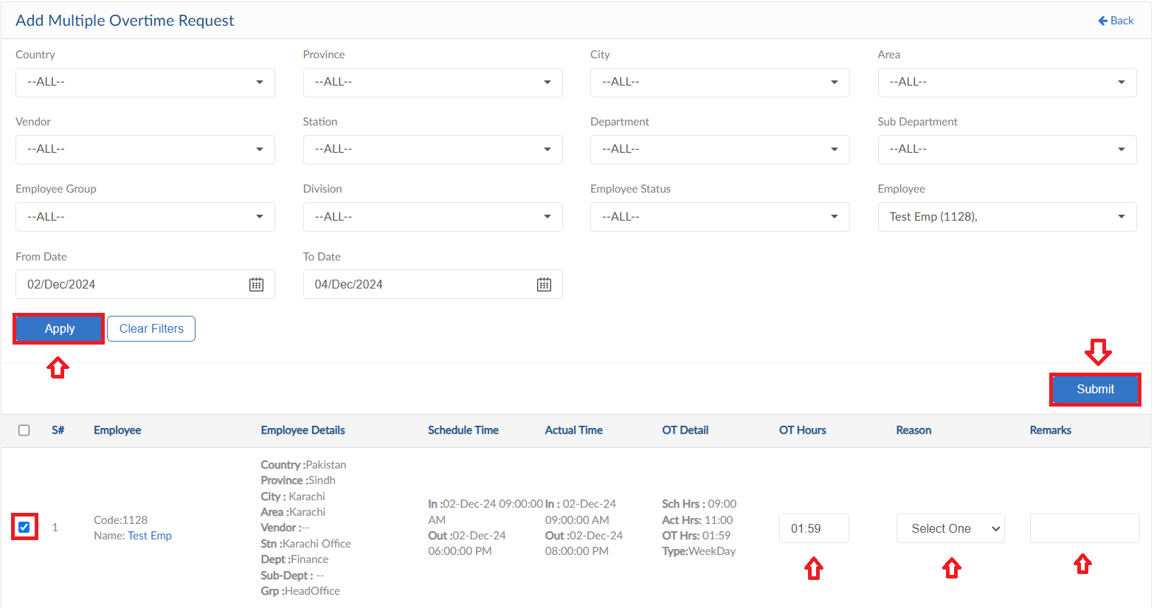

View Report
- To view the data of grid in Overtime Request form click on view report
- Overtime Request Report will pop up on screen

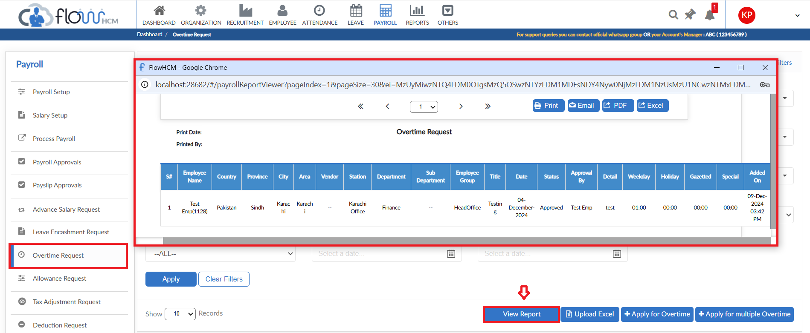

Reimbursement Request
- To add Reimbursement Request, click on Apply for Reimbursement
- Select the either to include in pay slip or not
- For details enter Date, select Category
- If required enter the Item number and Receipt number and then enter Amount
- User can add multiple lines for different details
- Enter a reason for request
- Then click on submit to raise a requisition

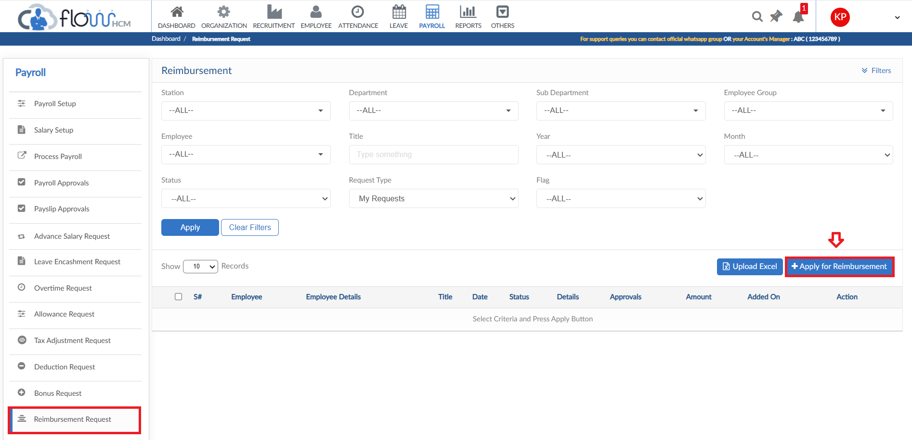
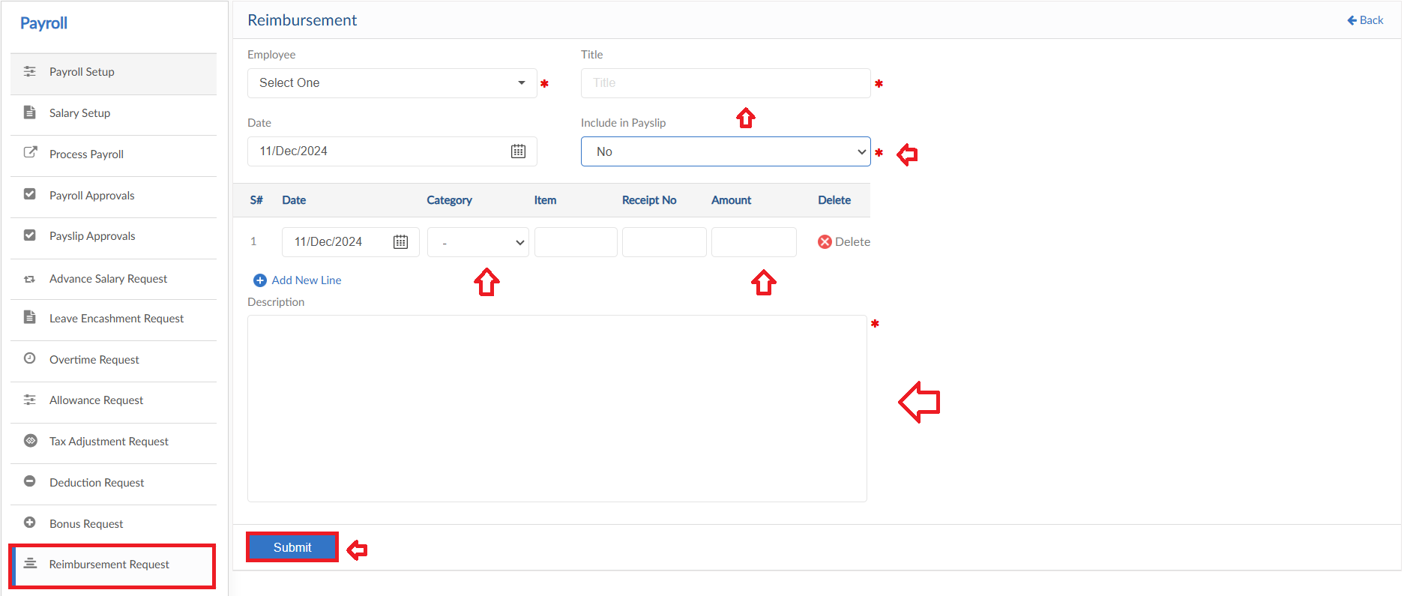

Commission Request
- To add Commission Request, click on Apply for Commission
- Select the employee from dropdown and enter Title of request
- Select date and enter the required amount
- Enter a reason for request
- Then click on submit to raise a requisition

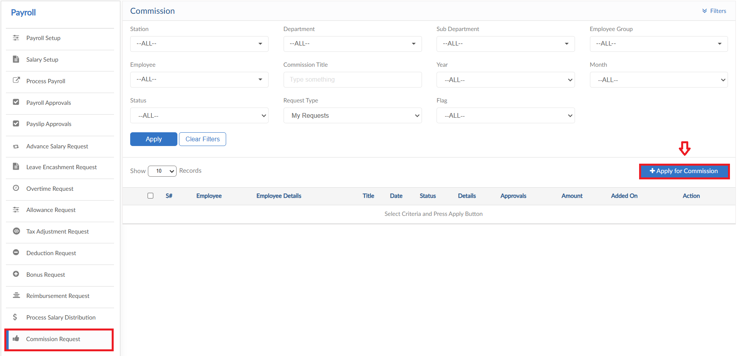
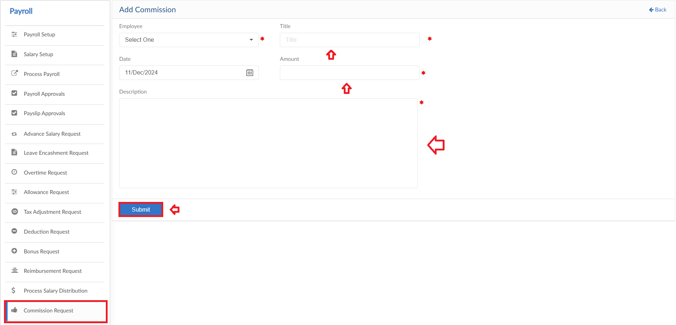

Loan Request
The form consists of multiple buttons/features
- To add General Loan Request, click on Apply for Loan (General) in Loan Request form
- Select the employee and Loan Type from dropdowns
- System will show the Loan History of selected employee
- Enter Date and Title for request
- Next, enter the Loan and Monthly Repayment amount
- Select the repayment start date
- Enter a reason for request
- Then click on submit to raise a requisition

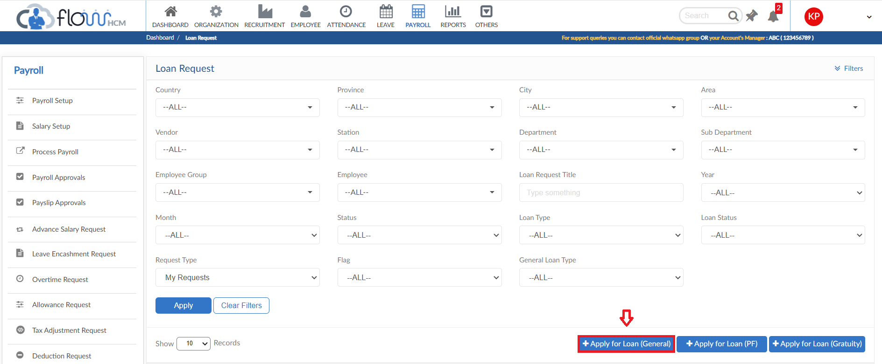
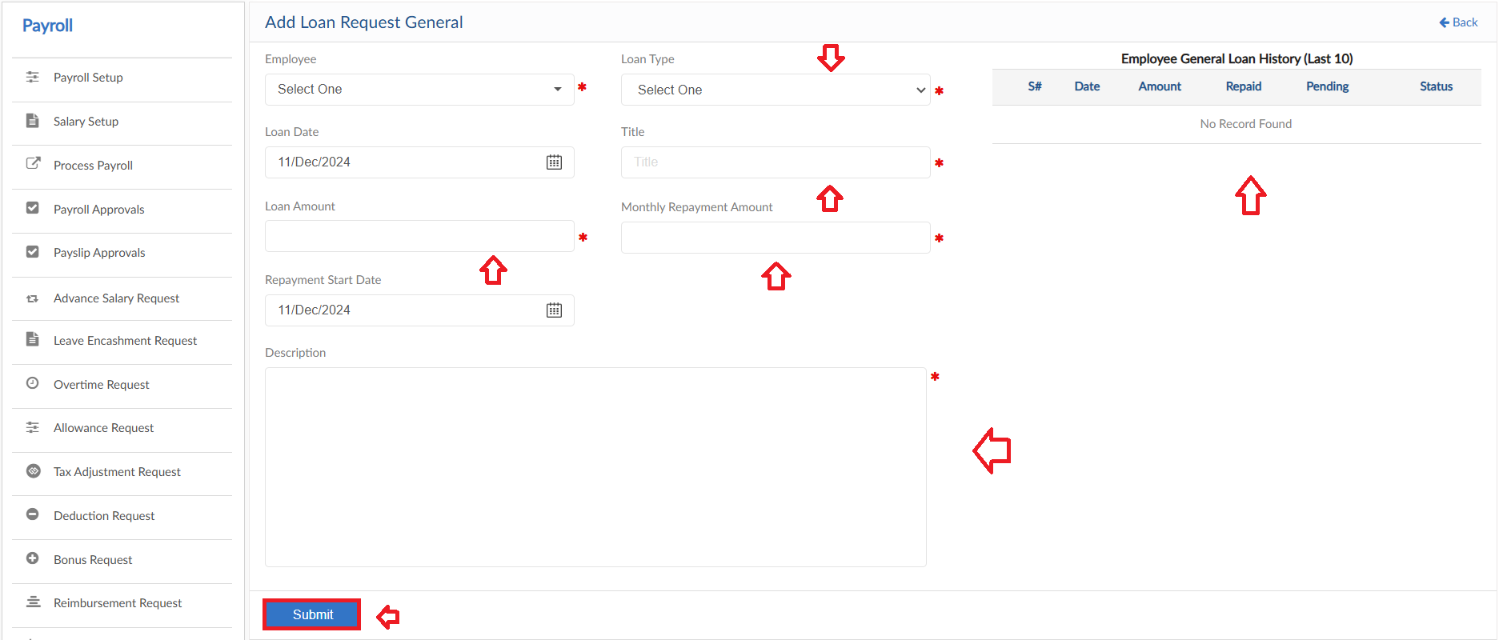

PF Loan
- To add PF Loan Request, click on Apply for Loan (PF) in Loan Request form
- Select the employee from dropdown and select loan date
- System will show the Loan History of selected employee
- Enter Title for request, system will show the PF balance amount
- Next, enter the Loan and Monthly Repayment amount
- Select the repayment start date
- Enter a reason for request
- Then click on submit to raise a requisition

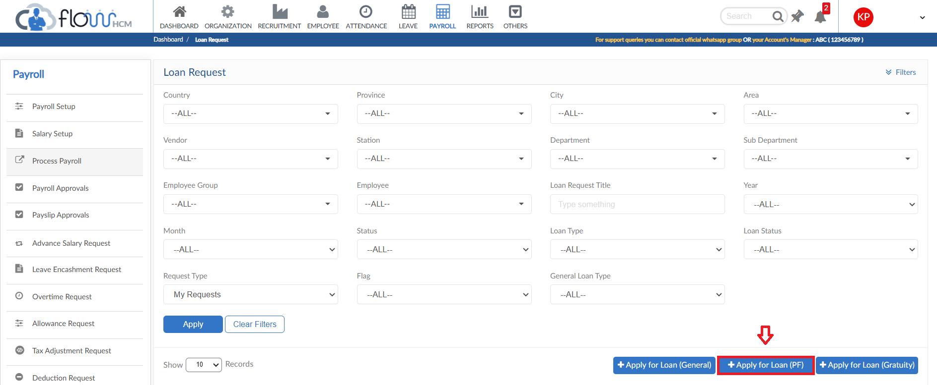
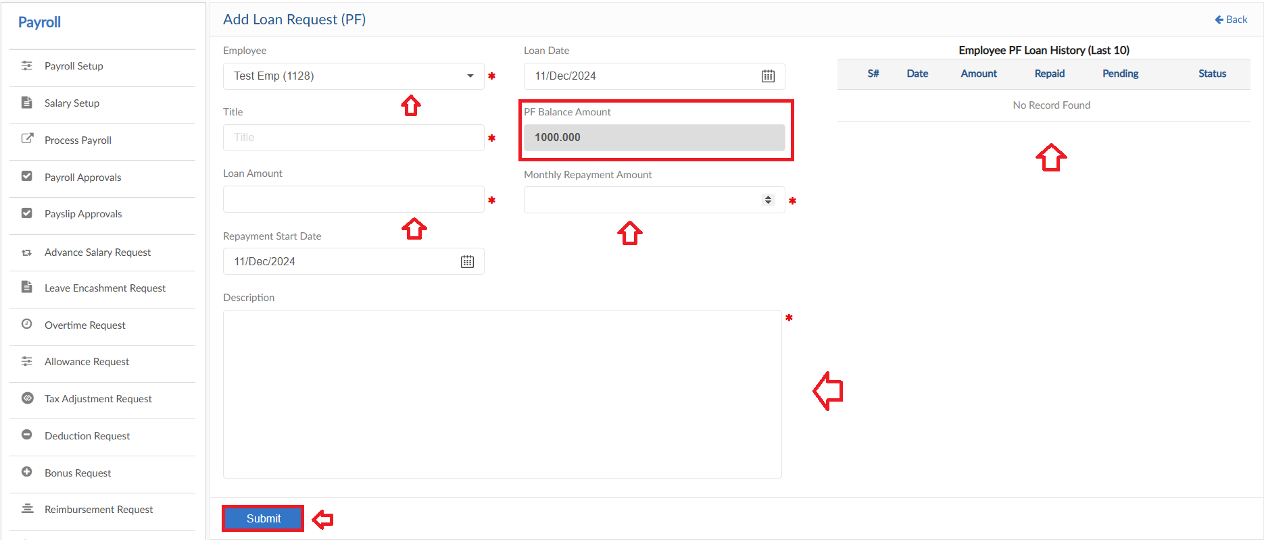

Gratuity Loan
- To add Gratuity Loan Request, click on Apply for Loan (Gratuity) in Loan Request form
- Select the employee from dropdown and select loan date
- System will show the Loan History of selected employee
- Enter Title for request, system will show the Gratuity balance amount
- Next, enter the Loan and Monthly Repayment amount
- Select the repayment start date
- Enter a reason for request
- Then click on submit to raise a requisition

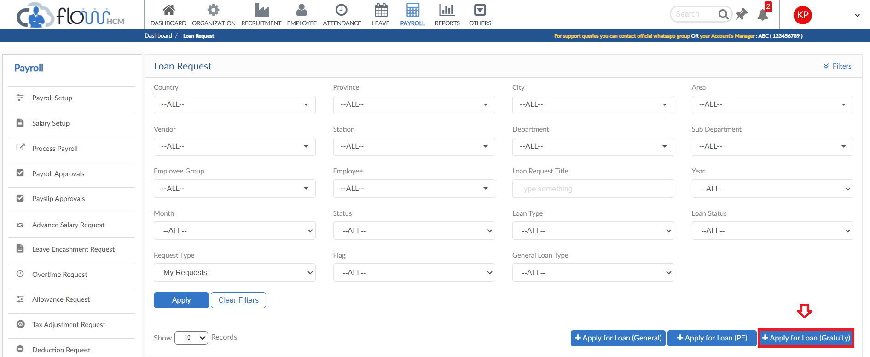
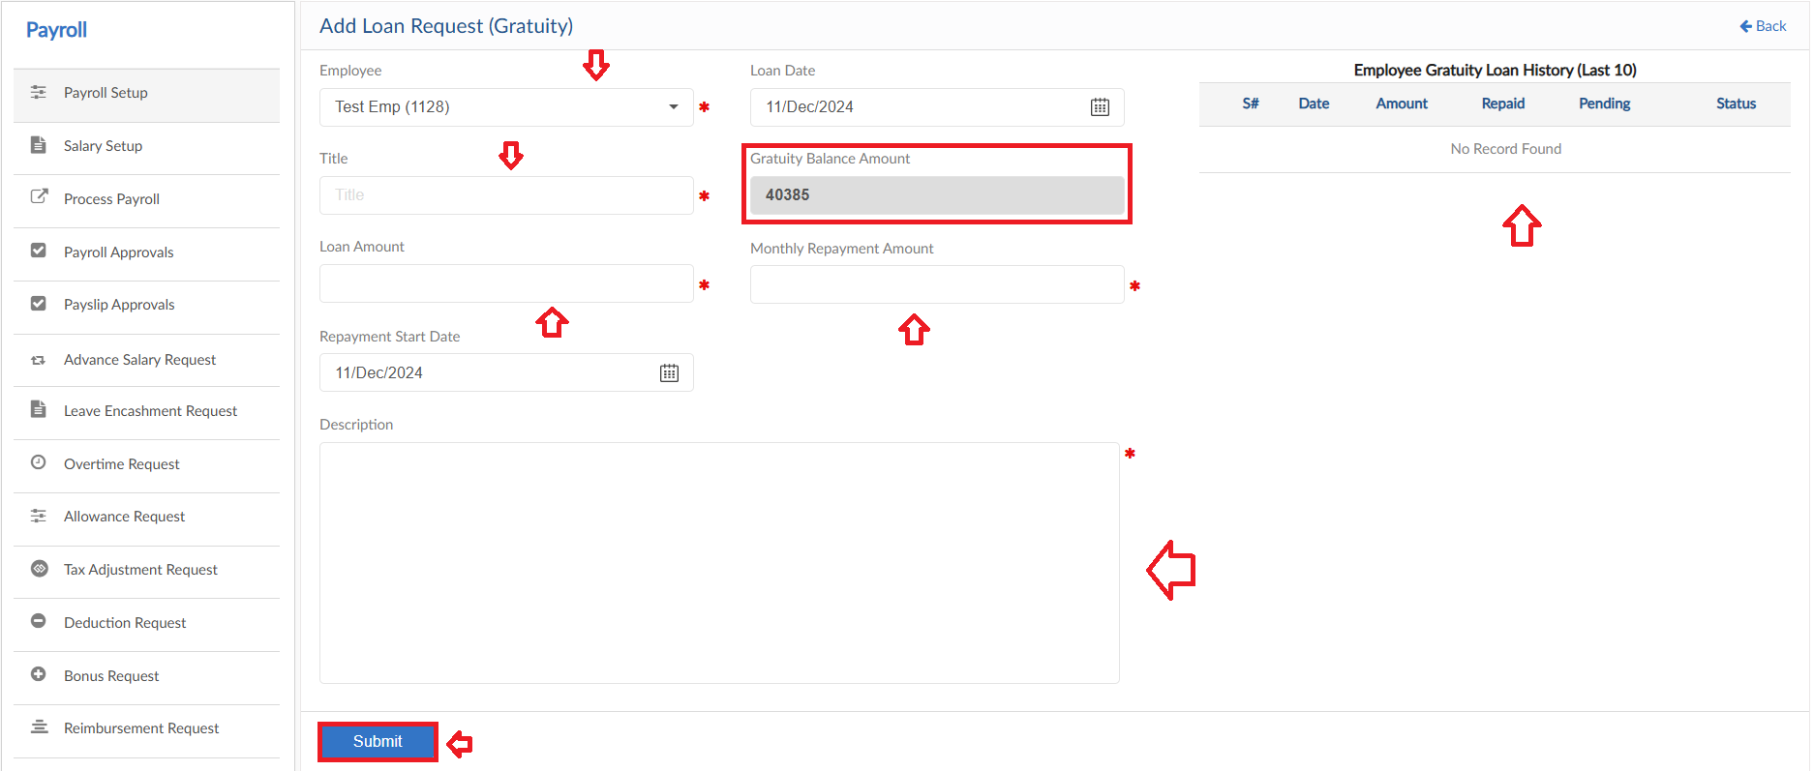

Loan Adjustment Request
The form consists of multiple buttons/features
- To add General Loan Adjustment Request, click on Apply for Adjustment (General)
- Select the employee and Loan Type from dropdown
- Enter Title for request and select Loan Adjustment type
- Select the Operation of Adjustment and date
- System will show the amount on the basis of Adjustment type then enter the amount
- Enter a reason for request
- Then click on submit to raise a requisition

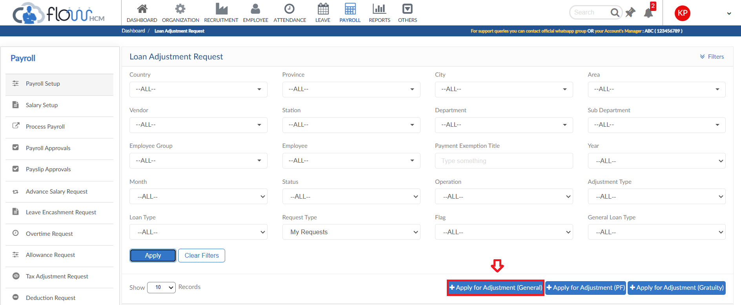
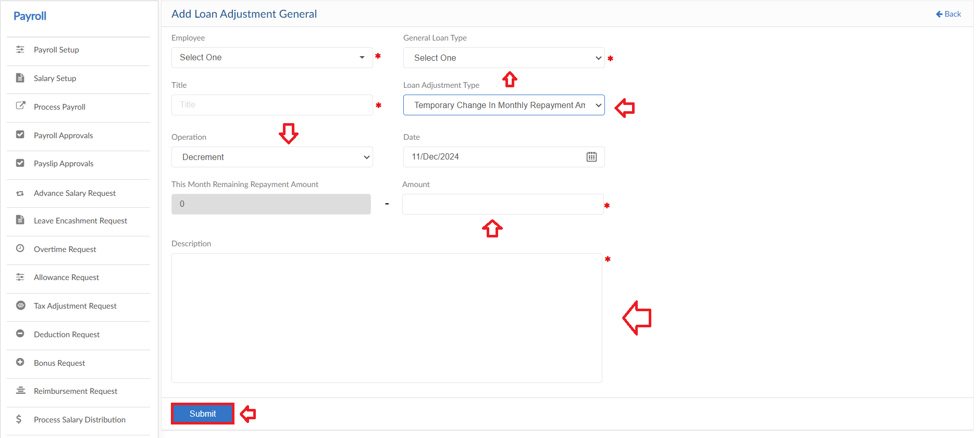

PF Loan Adjustment
- To add PF Loan Adjustment Request, click on Apply for Adjustment (PF) in Loan Adjustment Request form
- Select the employee from dropdown
- Enter Title for request and select Loan Adjustment type
- Select the Operation of Adjustment and date
- System will show the amount on the basis of Adjustment type then enter the amount
- Enter a reason for request
- Then click on submit to raise a requisition

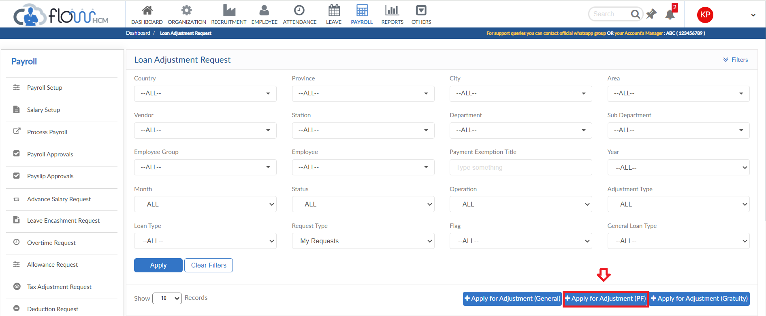
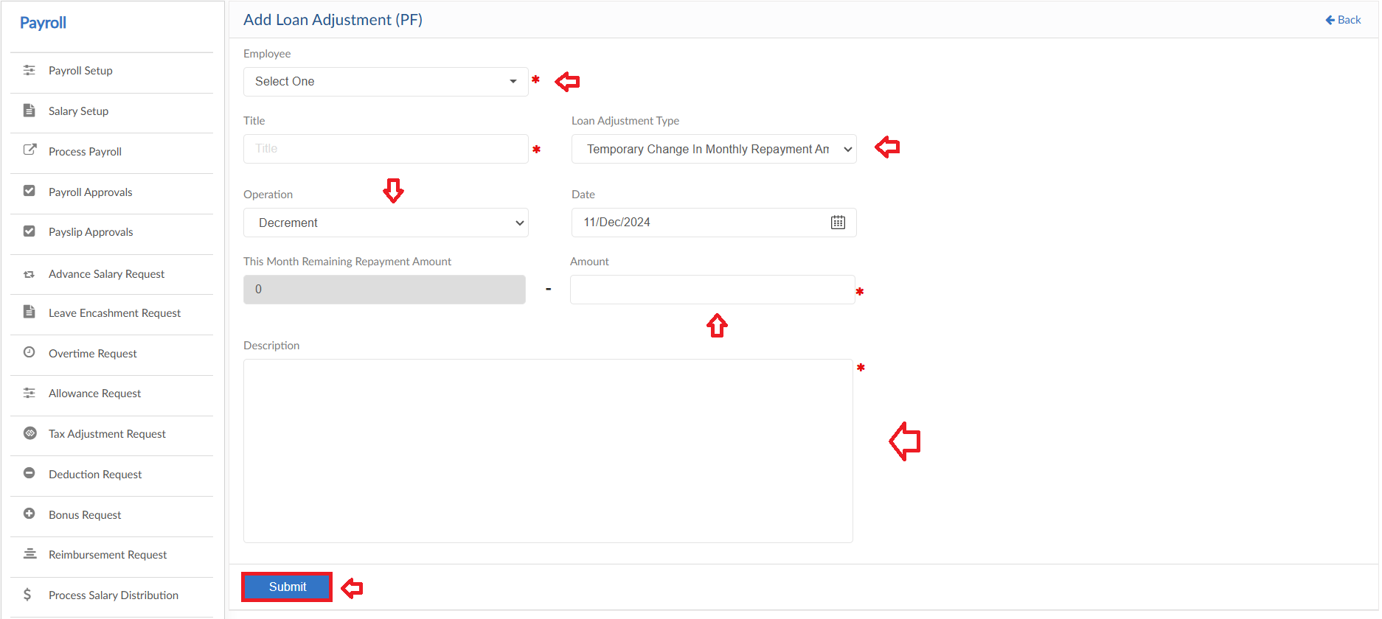

Gratuity Loan Adjustment
- To add Gratuity Loan Adjustment Request, click on Apply for Adjustment (Gratuity) in Loan Adjustment Request form
- Select the employee from dropdown
- Enter Title for request and select Loan Adjustment type
- Select the Operation of Adjustment and date
- System will show the amount on the basis of Adjustment type then enter the amount
- Enter a reason for request
- Then click on submit to raise a requisition

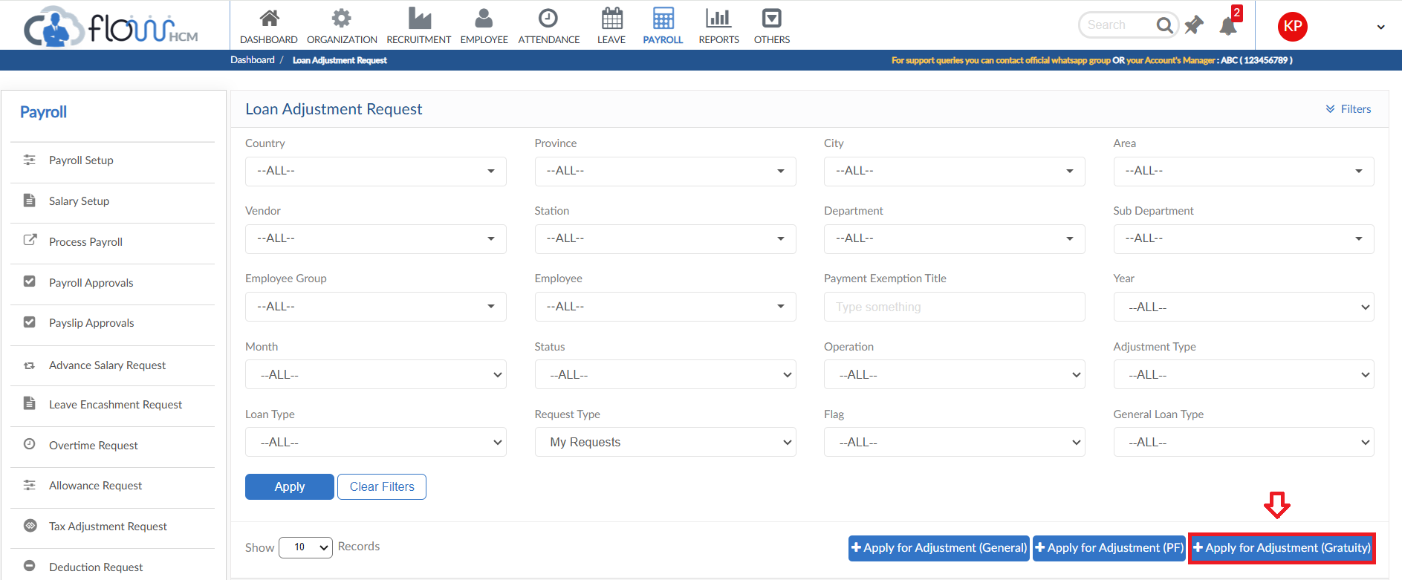
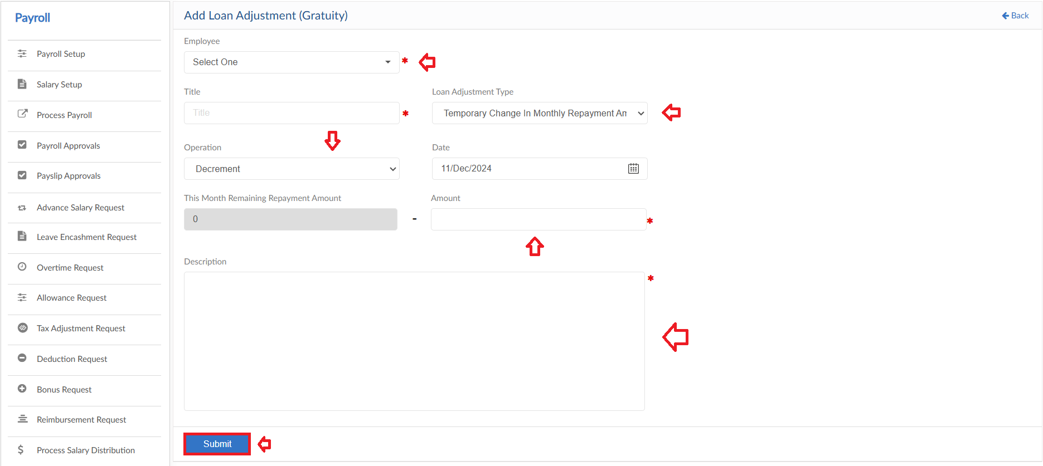

PF Withdrawal Request
- To add PF Withdrawal Request, click on Apply for PF Withdrawal in PF Withdrawal Request form
- Select the employee and enter title for request
- Select date and enter amount to withdraw
- System will show PF Withdrawal History
- Enter a reason for request
- Then click on submit to raise a requisition

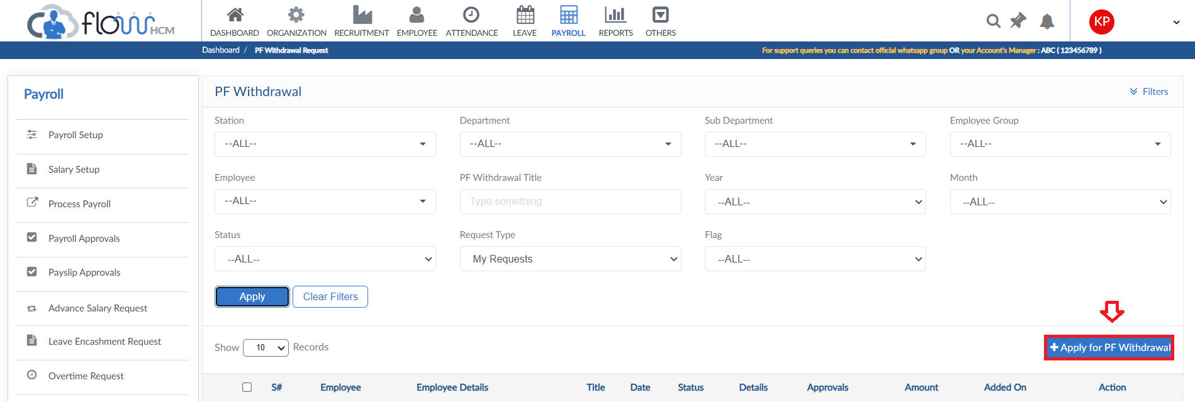
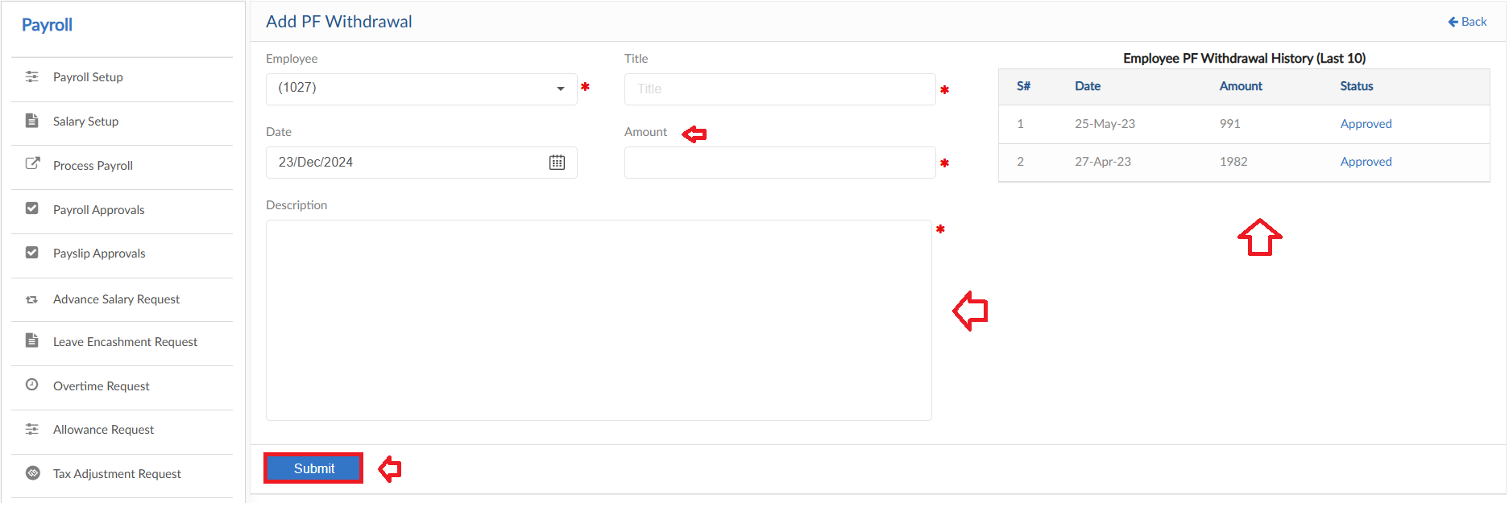

Employee Module

Employee Info Request
- To add an Info Request, click on Employee Info Request form
- Click on Apply for Employee Info button
- Select Employee from dropdown, system will autofill fields
- User can only change the data in enabled fields
- After the changes click on Submit request to raise a requisition

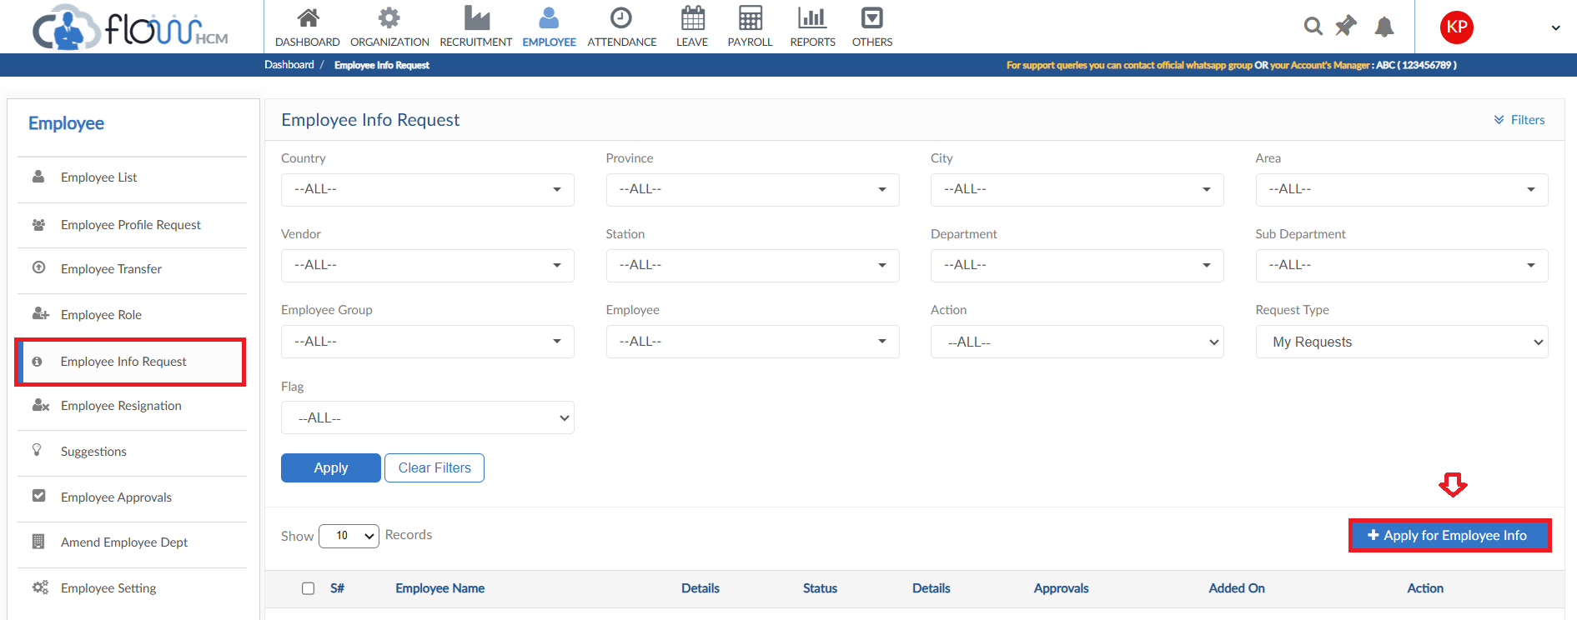
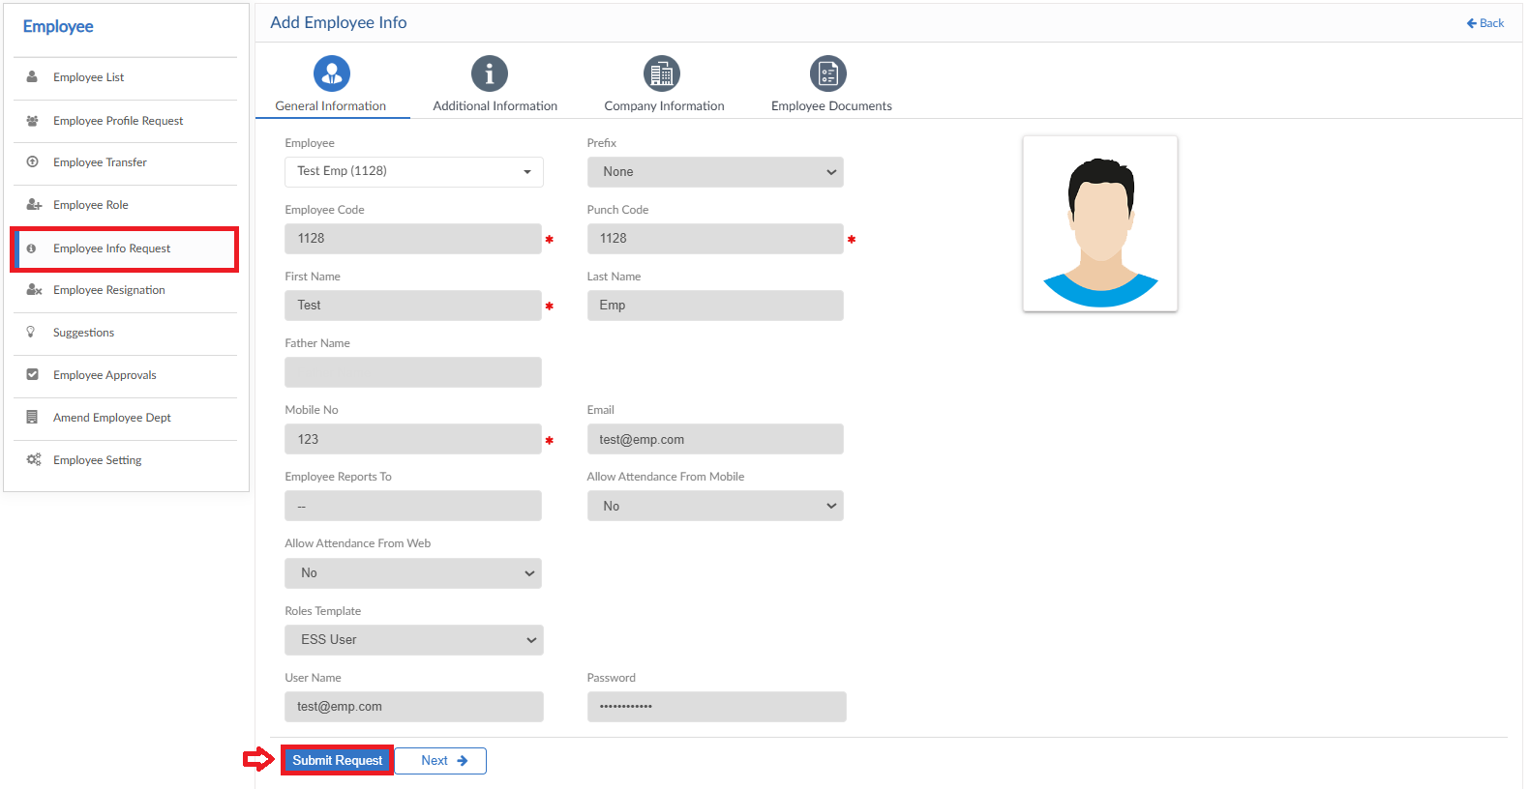

Employee Resignation
- To add a Resignation Request, click on Employee Resignation form
- Click on Add New Request button
- Select Employee and Resignation date
- Define resignation reason and enter Last working date
- File can be attached if required
- Enter a reason for request then click on Submit button to raise a requisition

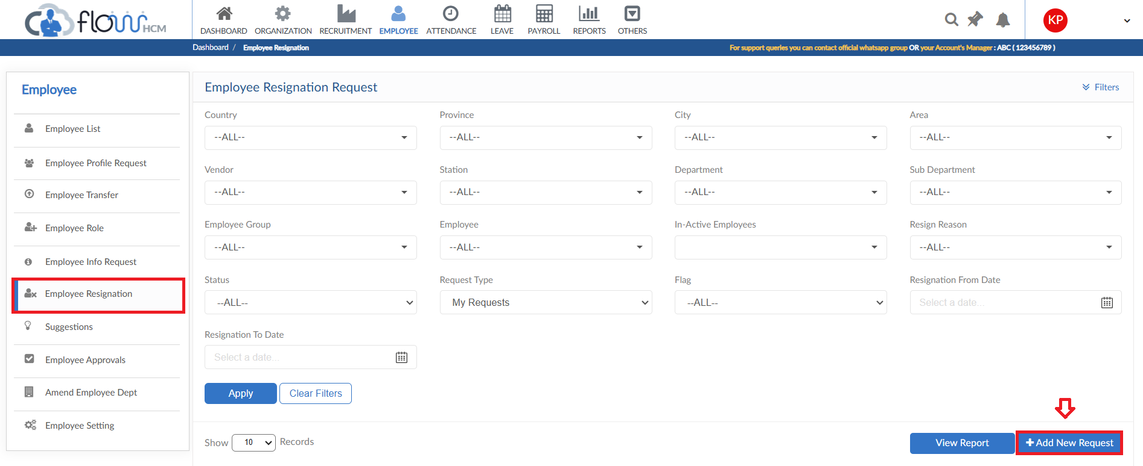
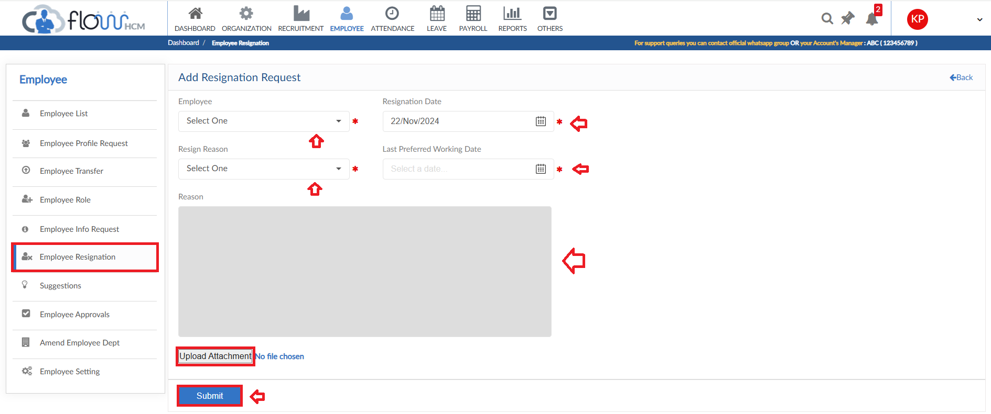

View Report
- To view the data of grid in Employee Resignation form click on view report
- Resignation Request Report will pop up on screen

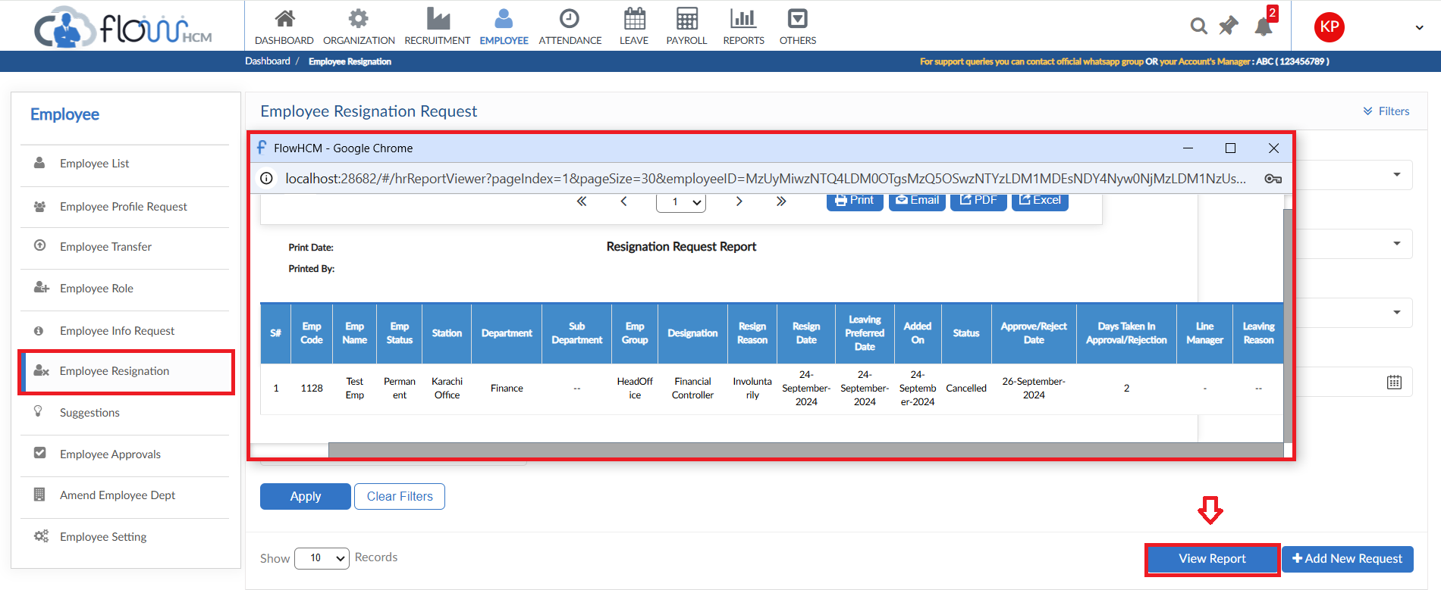

Suggestions
- To add a Suggestion Request, click on Add New Suggestion
- Enter Suggestion Title and Select category from dropdown
- Select either the suggestion should be sent anonymously or not
- Define the suggestion in box
- Then click on submit to raise a requisition

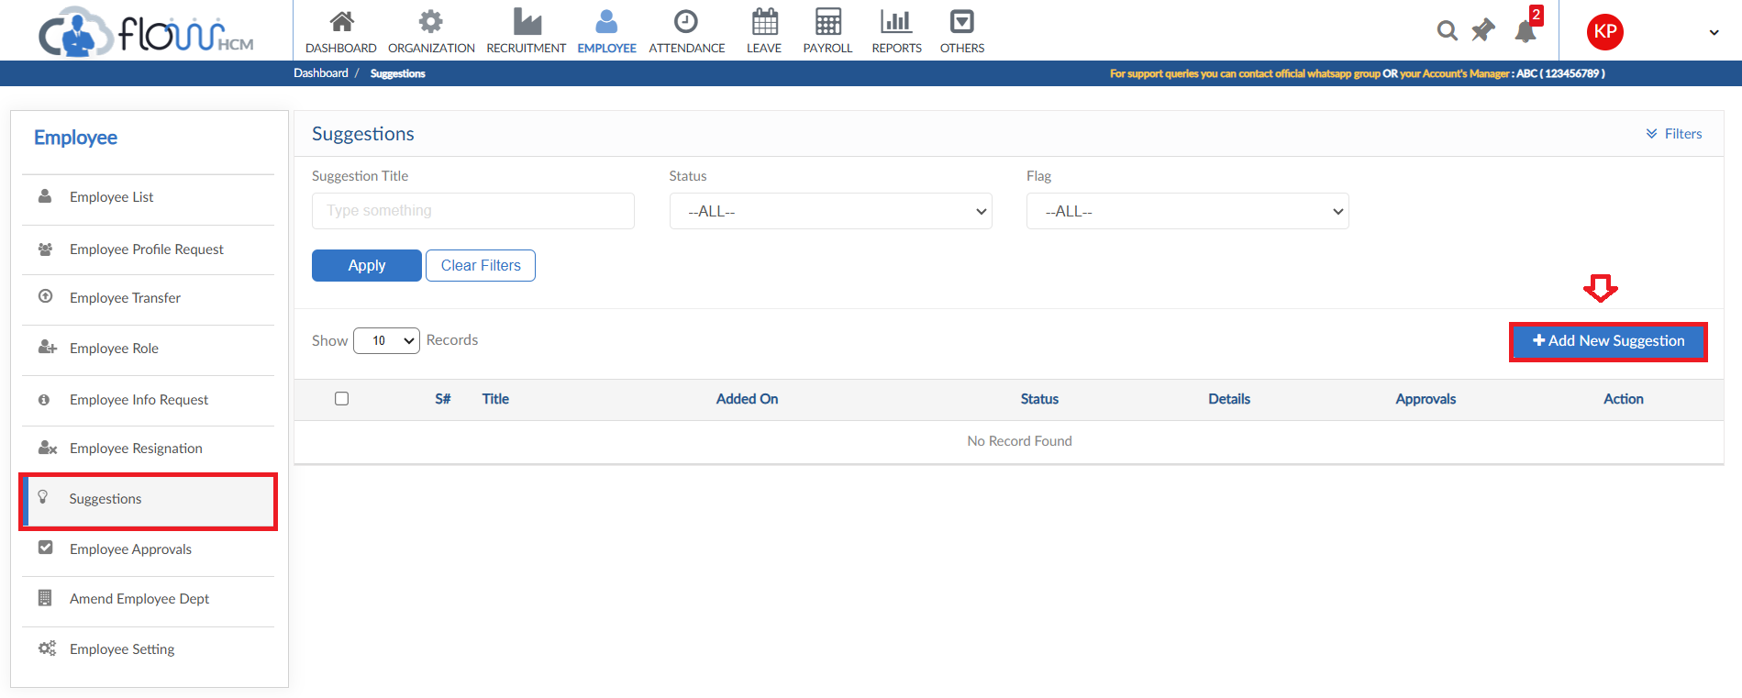
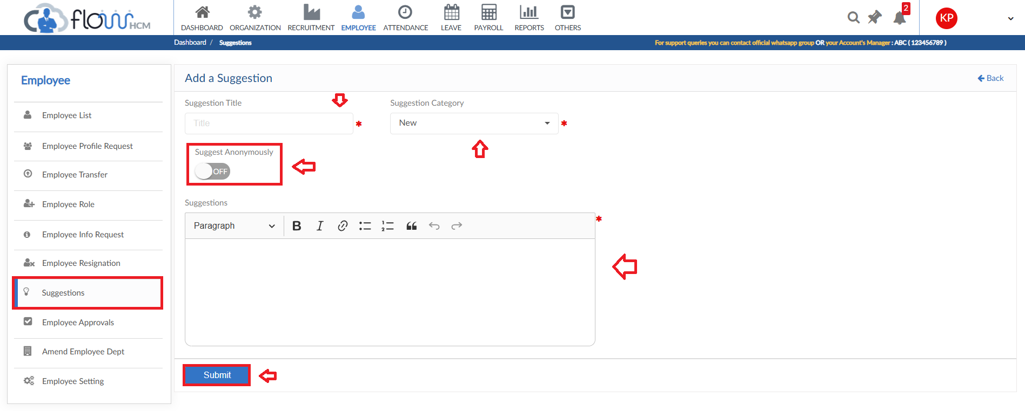

Performance Module

Performance Evaluation
- Evaluation Tab will show the pending/completed evaluation of Employee
- Grid will show all the details of Employee Review
- Click on Evaluate in Action dropdown
- Evaluation from will be visible as per parameters set
- User can score and add comments through this form
- Additional employee feedback tiles are also available to fill
- In the end weightage and final score will be shown as per user scoring
- Click on Submit Performance Evaluation button

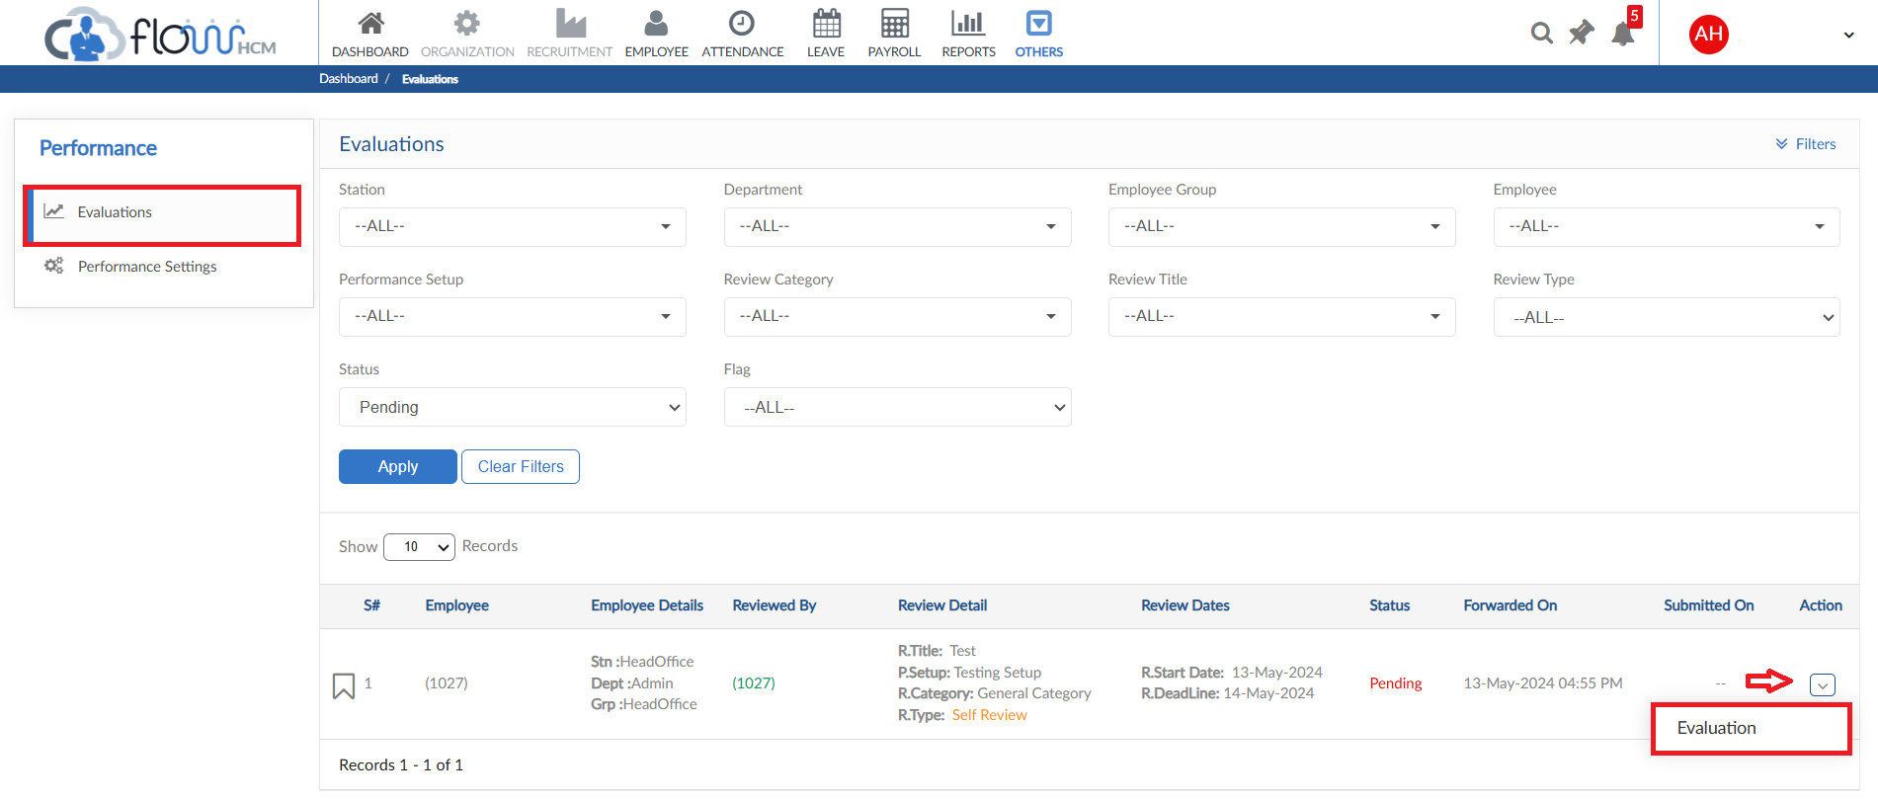

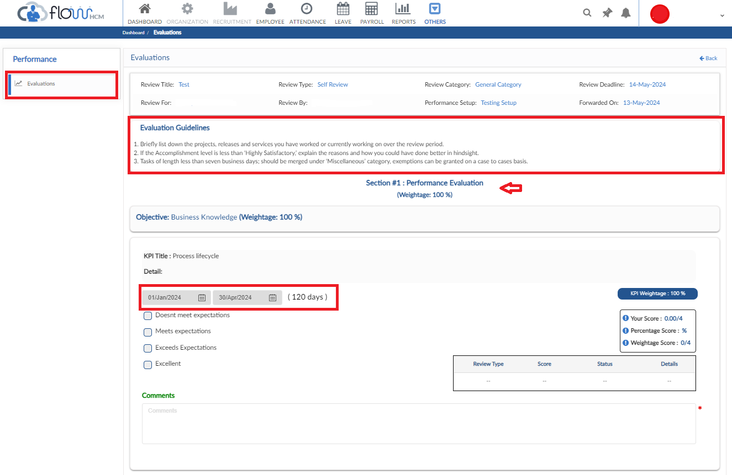
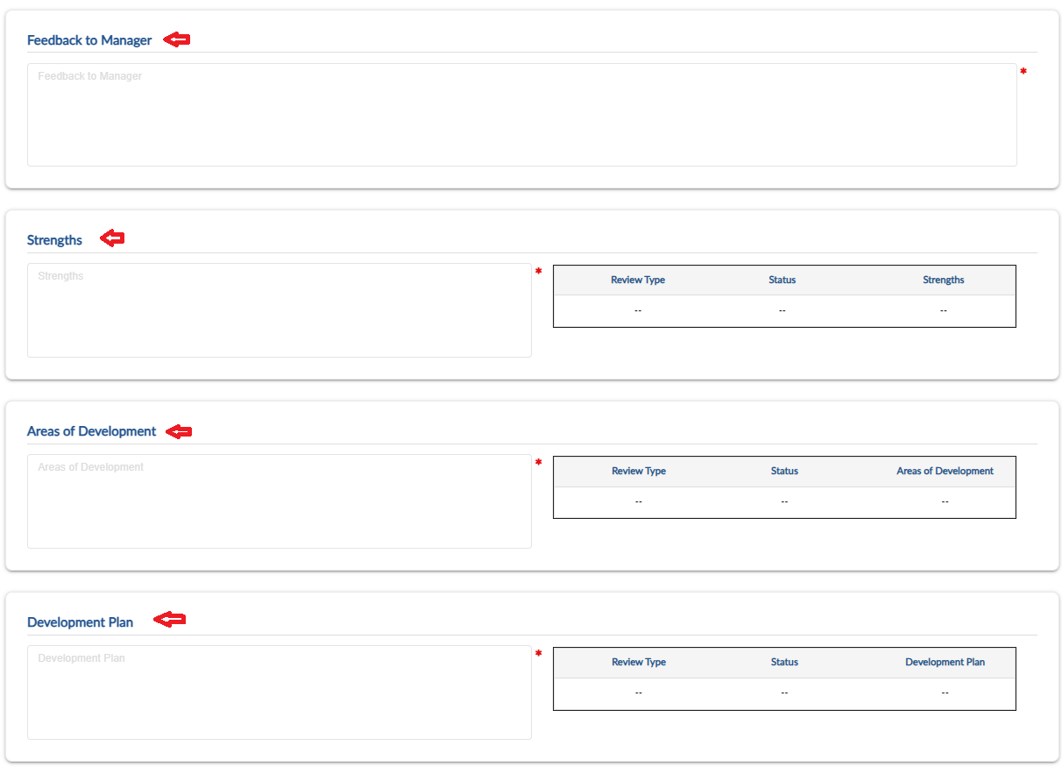
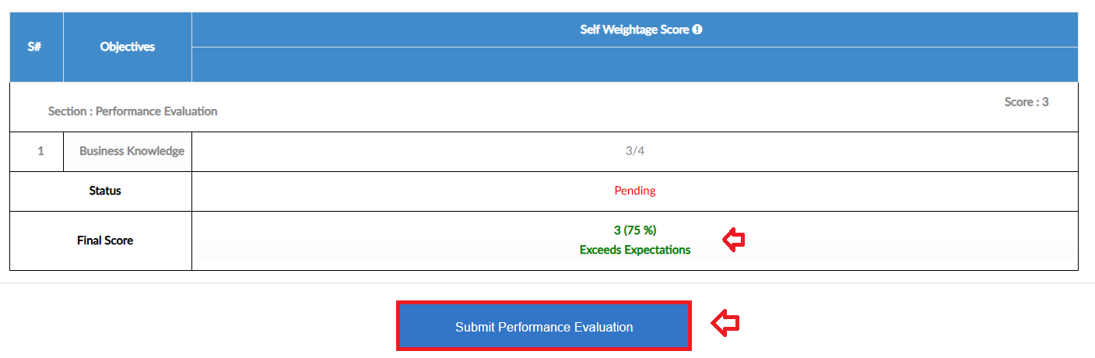

Expense Module

Expense Request
- Navigate to Others Tab and click Expense Module
- For Expense Request, click on Apply for Expense
- Select employee, category, month and year for expense
- In case of request against advance select Yes in dropdown
- Set date and type of expense, enter amount
- User can add multiple lines in a single request
- If any previous record is in the system it will show the detail
- Attach a file if required and check or uncheck include in payroll option
- Enter description and then submit the request

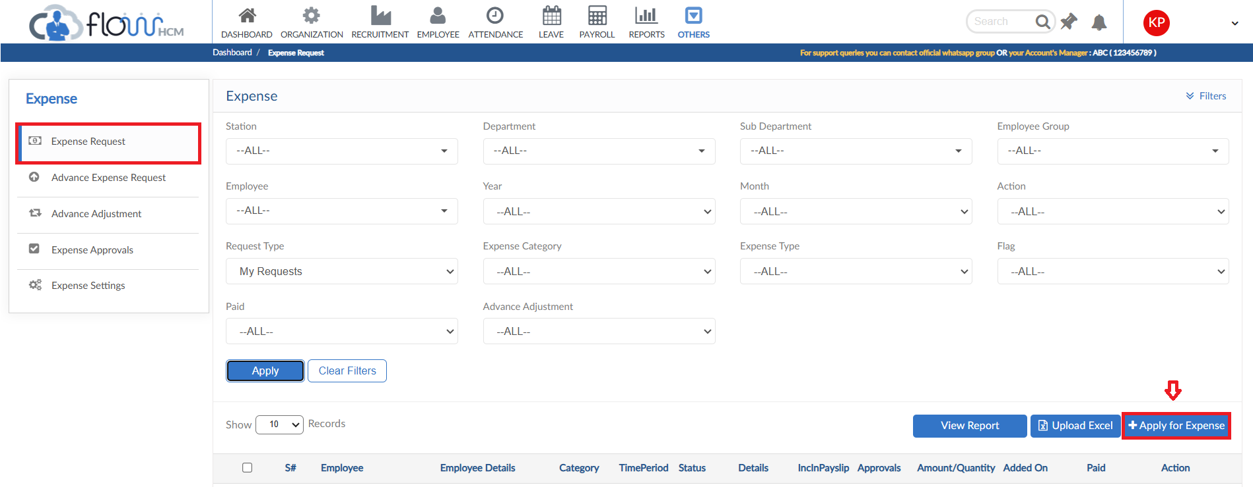
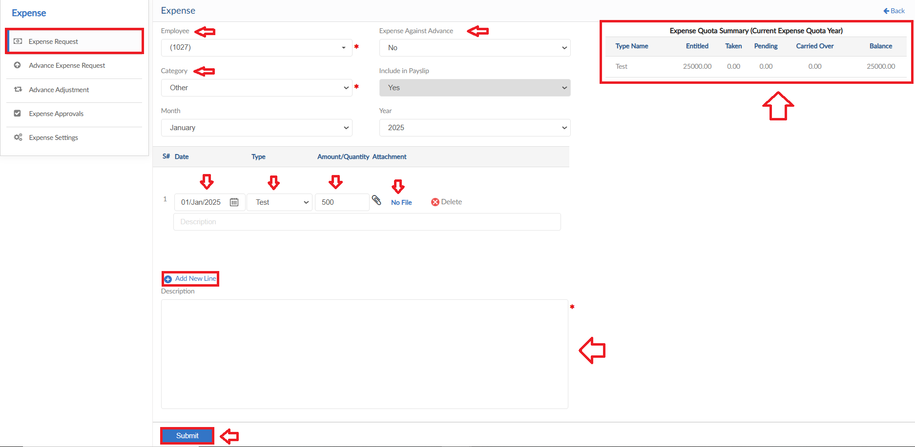

View Report
- To view the data of grid in Expense Request form click on view report
- Expense Request Report will pop up on screen

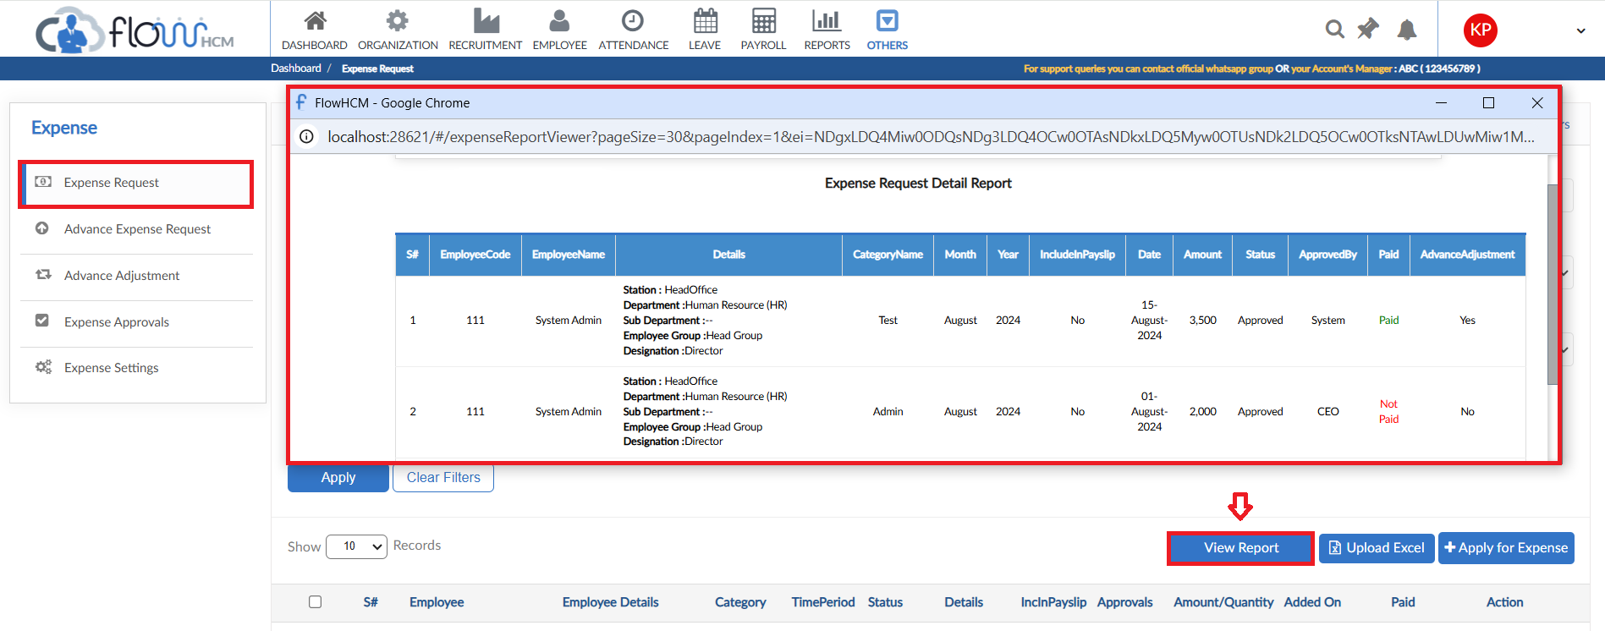

Advance Expense Request
- For Advance Expense Request, click on Apply for Advance Expense
- Select employee, category, month and year for request
- Set date and type of expense, enter amount
- User can add multiple lines in a single request
- Attach a file if required
- Enter description and then submit the request

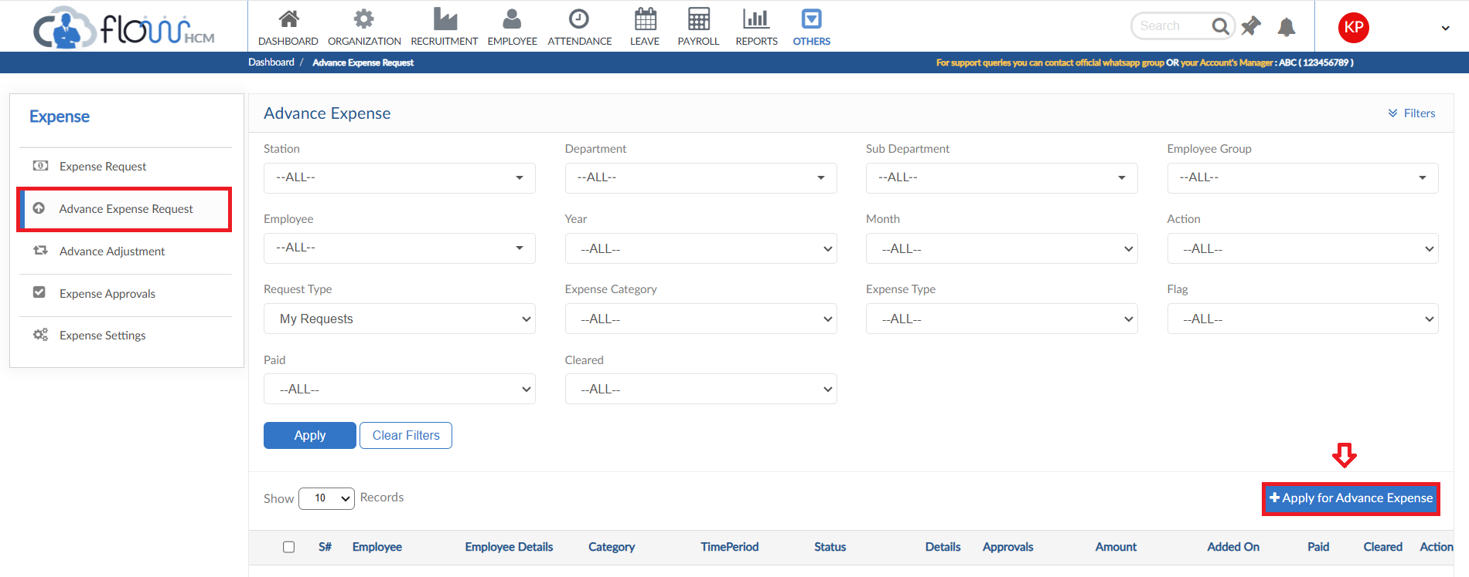

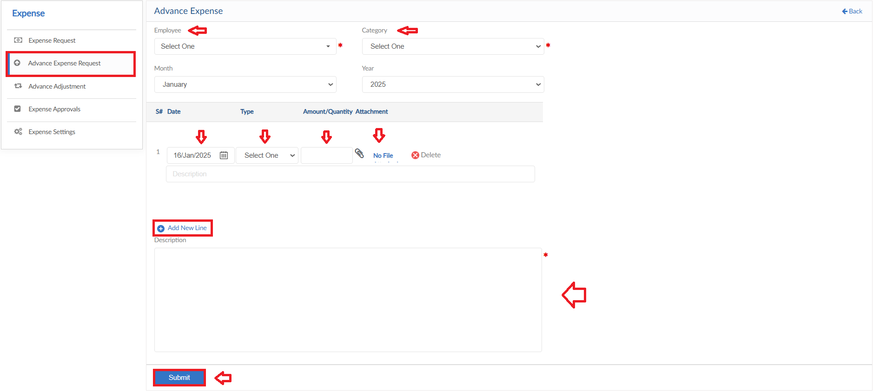

Advance Adjustment
- For Advance Adjustment Request, click on Apply for Advance Adjustment
- Select the employee and Category from dropdowns
- Define the type, system will show the Remaining amount
- Select the Operation from dropdown (Increment/Adjustment) and enter the amount
- Define a date and enter a reason for request
- Then click on submit to raise a requisition

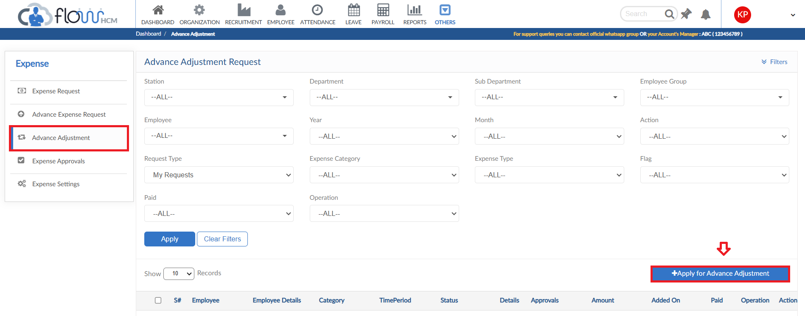
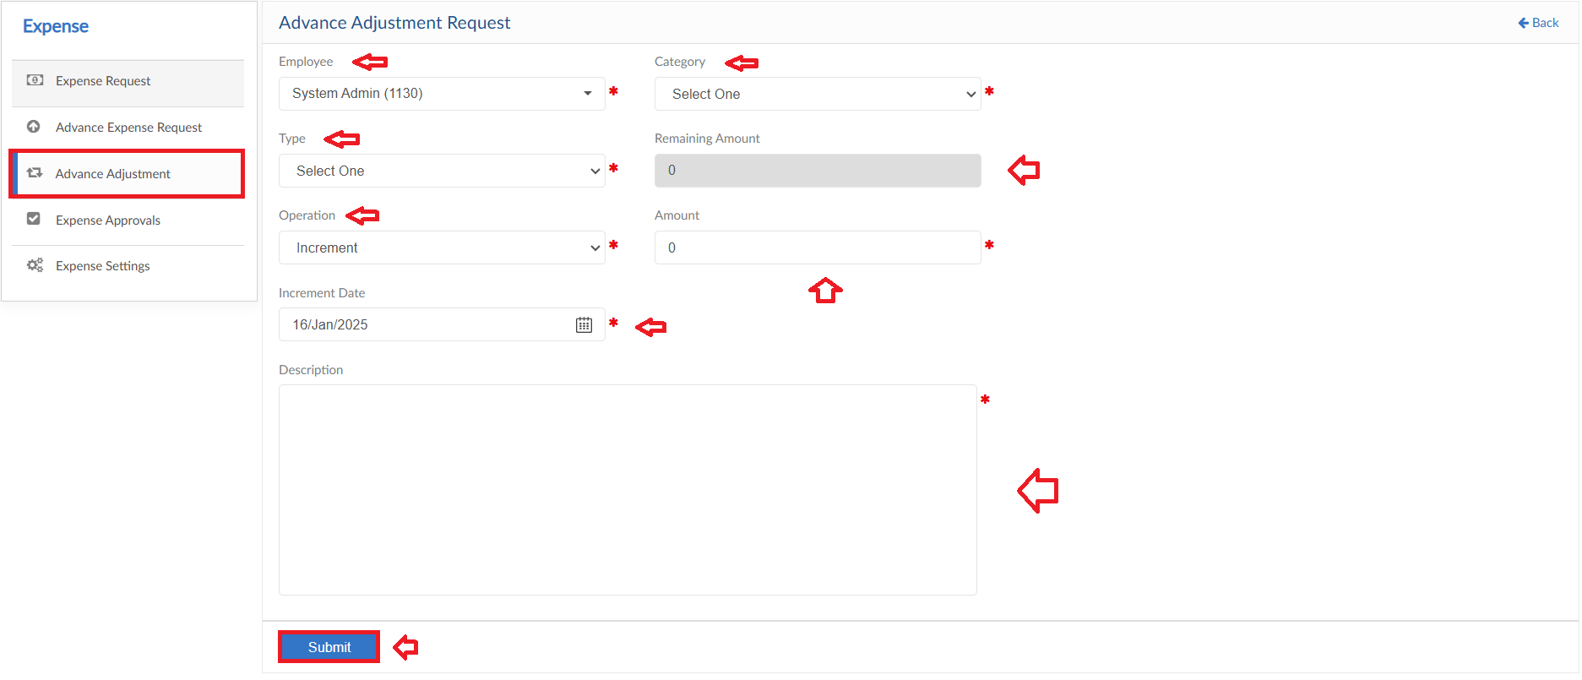

Travel Module

Travel Request
- For Travel Request, click on Add New Request
- The form has multiple Tabs to fill information
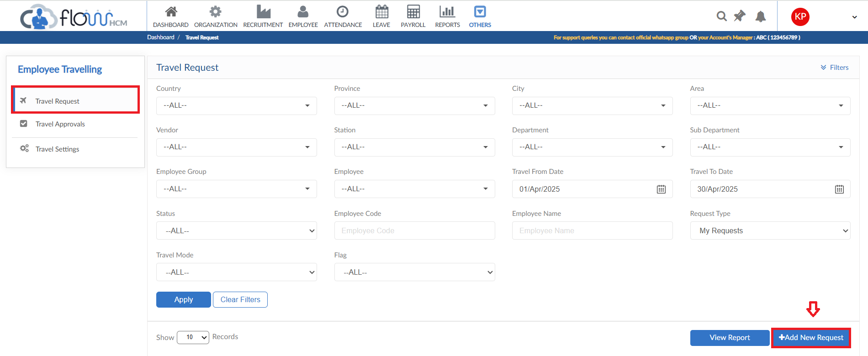

General Details
- In this Tab, select travel mode and employee from dropdowns
- Enter trip Start and End date
- Define Reason type and enter reason
- If required file can be attached
- Click Next button
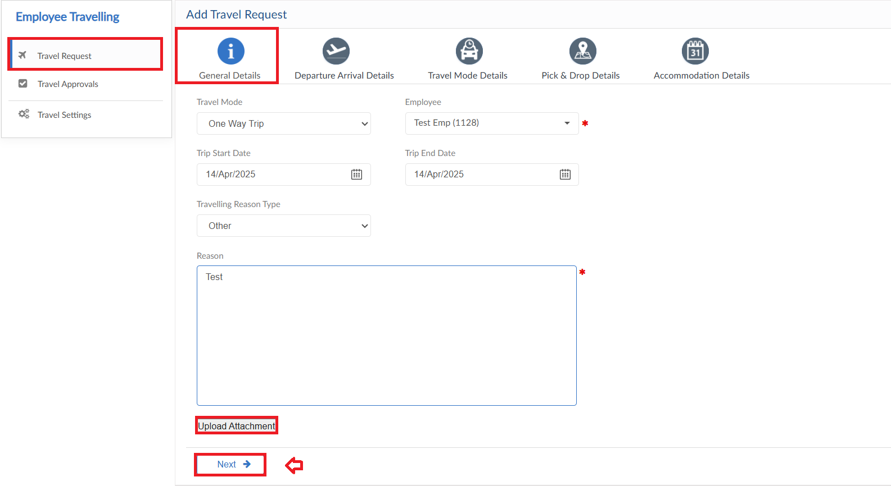

Departure Arrival Details
- In this Tab, select the country and city for Departure
- Define the country and city for Arrival and click Next button
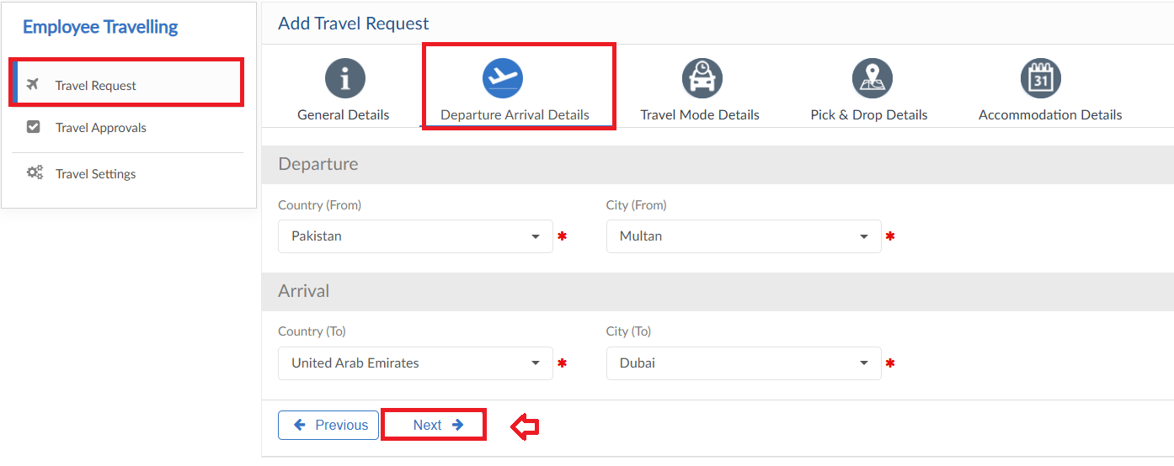

Travel Mode Details
- In this Tab, define Travel Time
- Select Travel Conveyance and class then click Next button
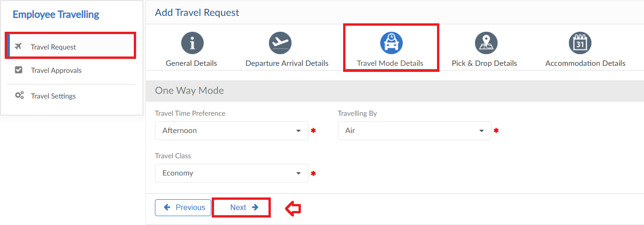

Pick & Drop Details
- In this Tab, Pick and Drop details will be entered
- If required select Yes and enter details and click Next button
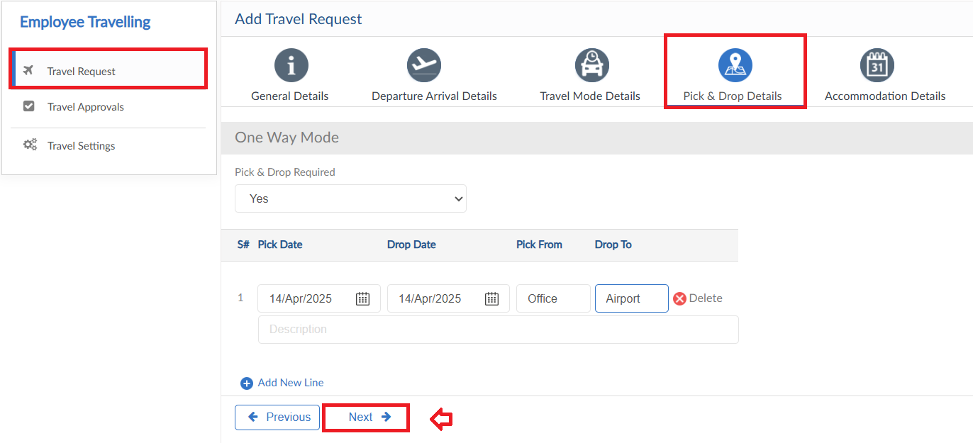

Accommodation Details
- In this Tab, Accommodation details will be entered separately
- Enter the required Company and Personal accommodation details
- Click Submit button to raise a requisition
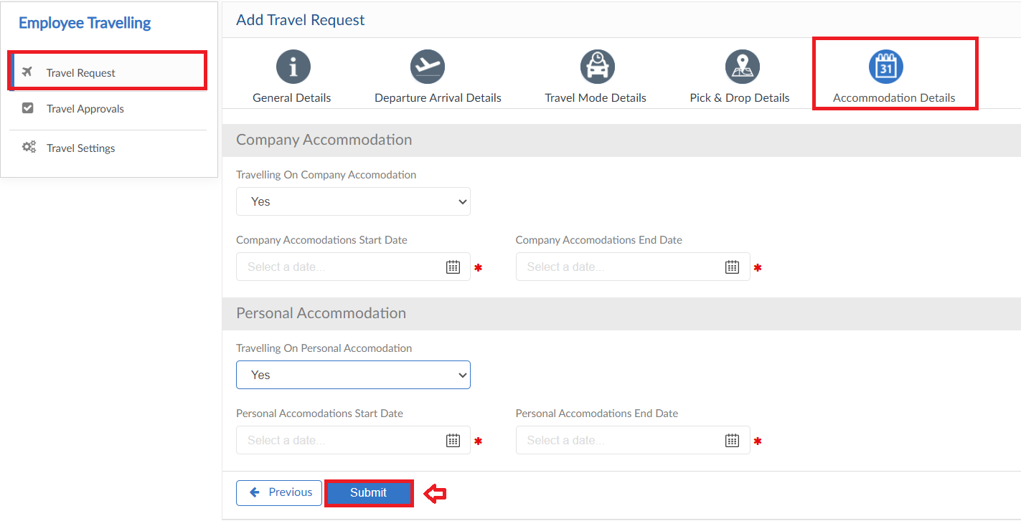

Helpdesk Module

Ticket Request
- For Ticket Request, click on Add Ticket Request
- Select the employee from dropdown and enter Ticket Title
- Select the category, Type and Priority of the ticket from dropdowns
- Enter description for the ticket and upload attachment if required then submit the request
- The system will also show Ticket History of the selected employee
- The User can see the requested Ticket in the grid, go on action button to view the ticket or cancel the request
- Ticket Request screen has a brief dashboard as well, click on Show Status Bar

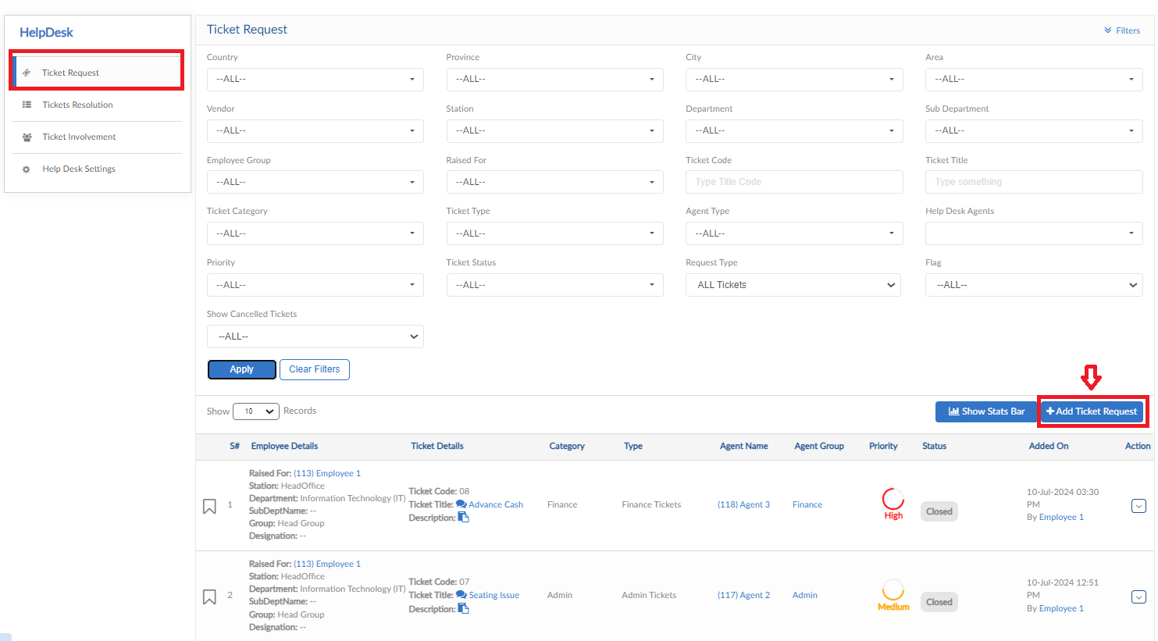
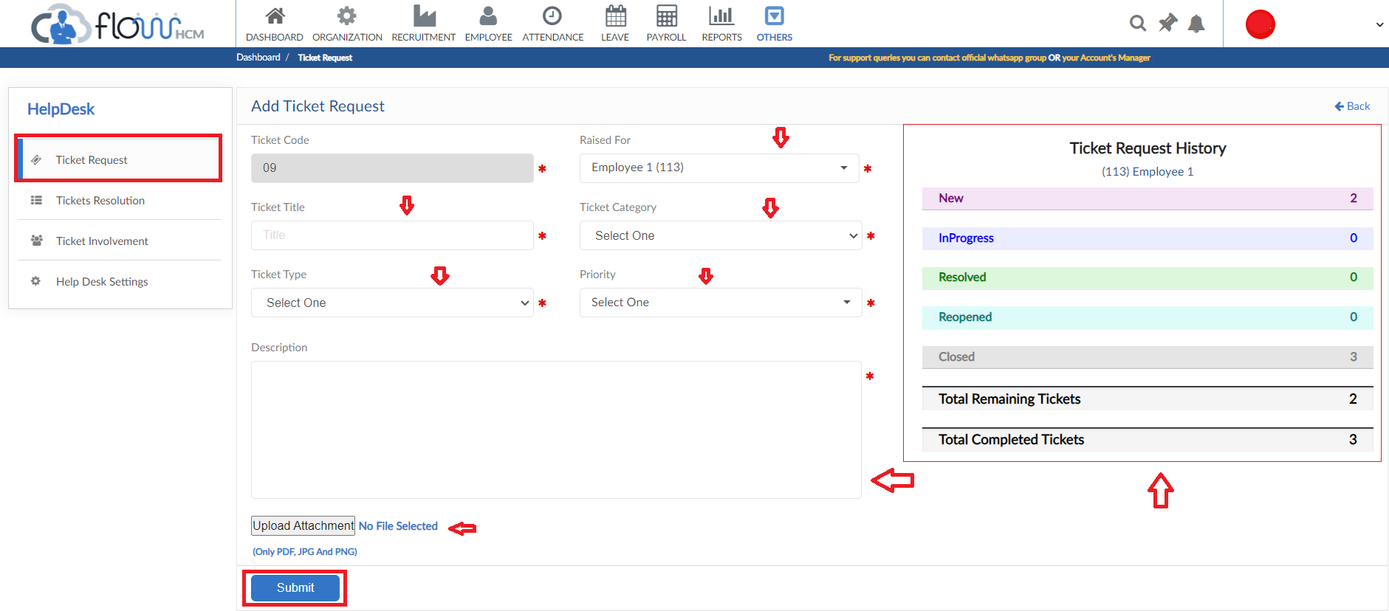
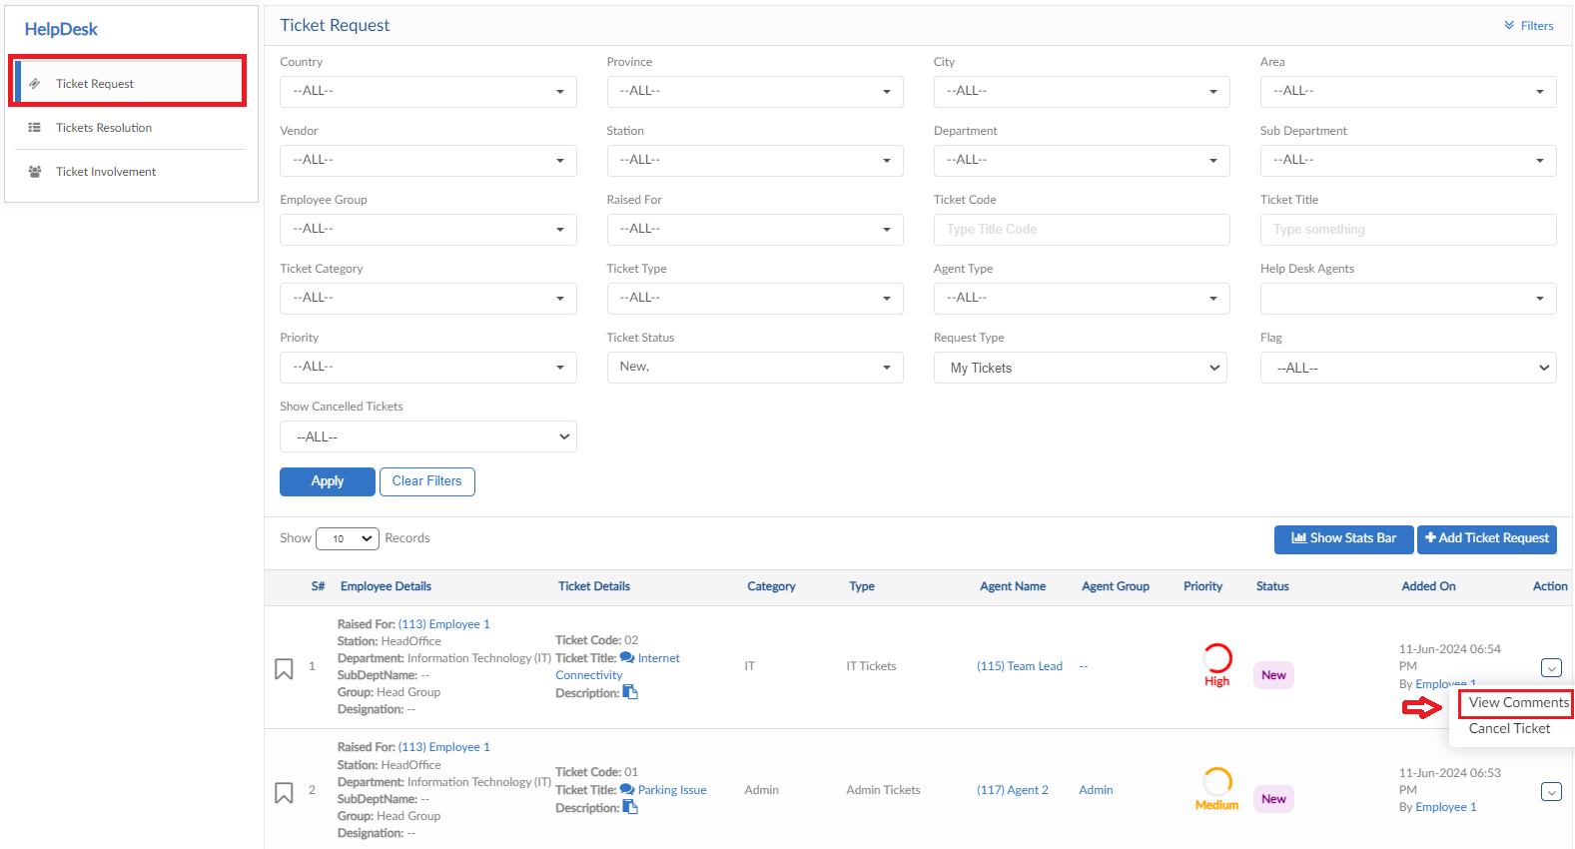
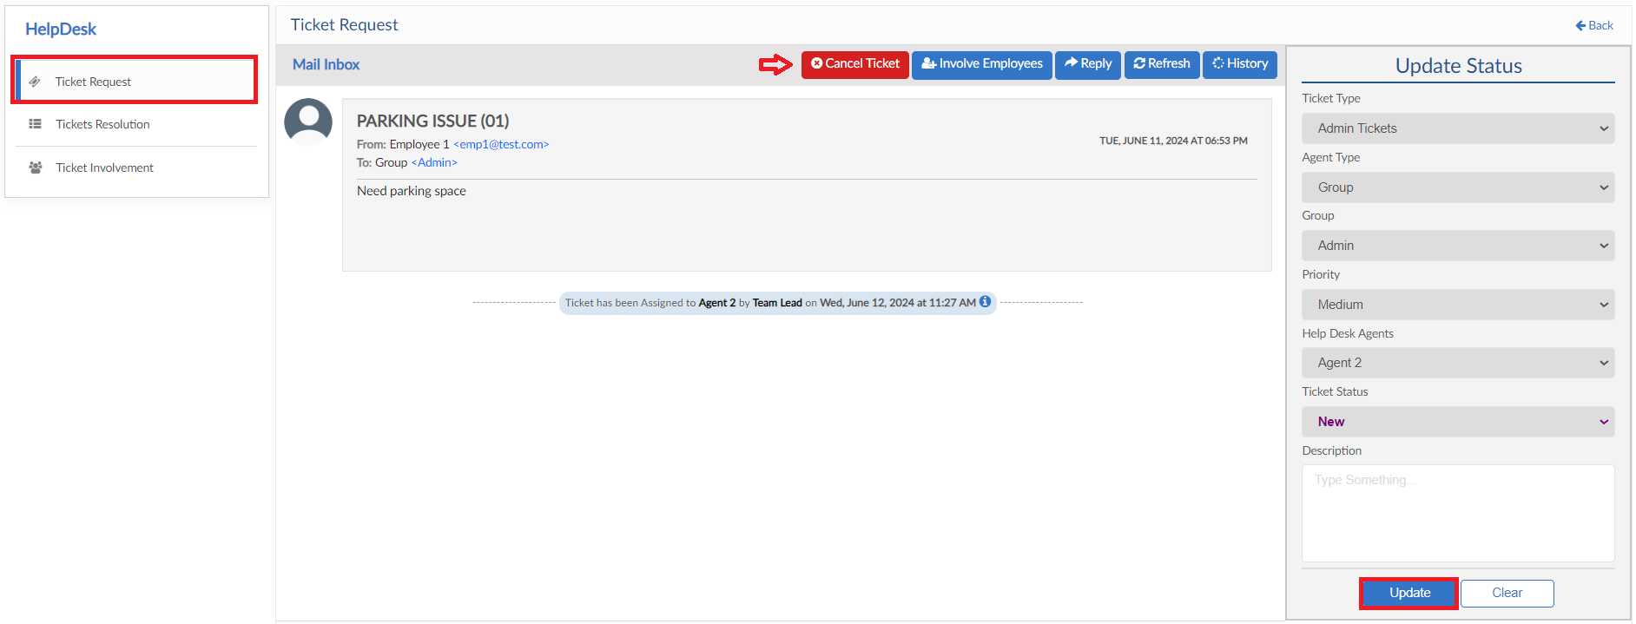

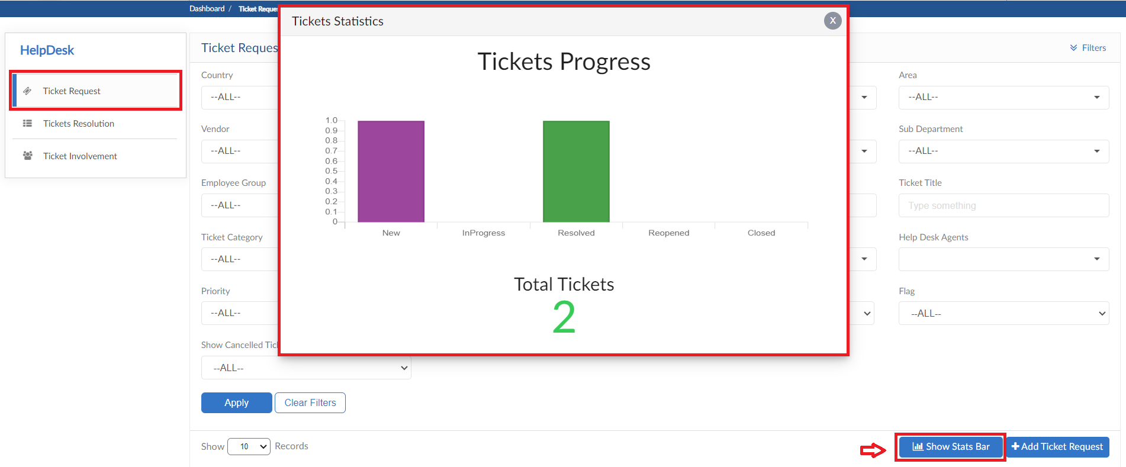

Ticket Resolution
- This screen is for the agents to resolve the assigned tickets
- Click on Action button to view the ticket
- Agent can change the Ticket status, add a description and also reply to the requester
- Reply functionality contains tagging employees that part of that ticket
- Ticket Resolution screen also has a Status Bar dashboard

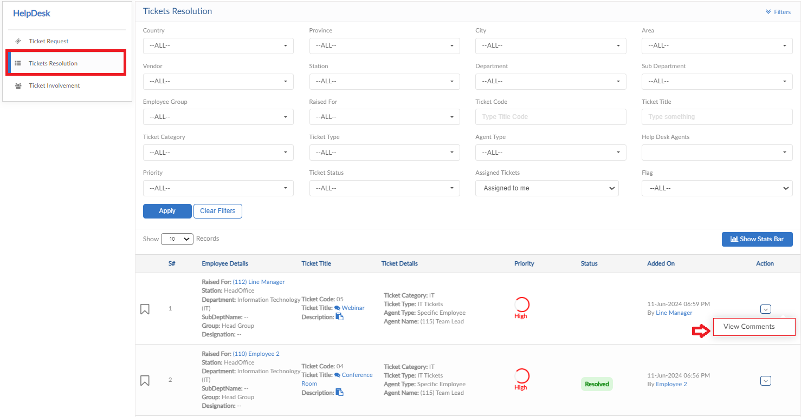
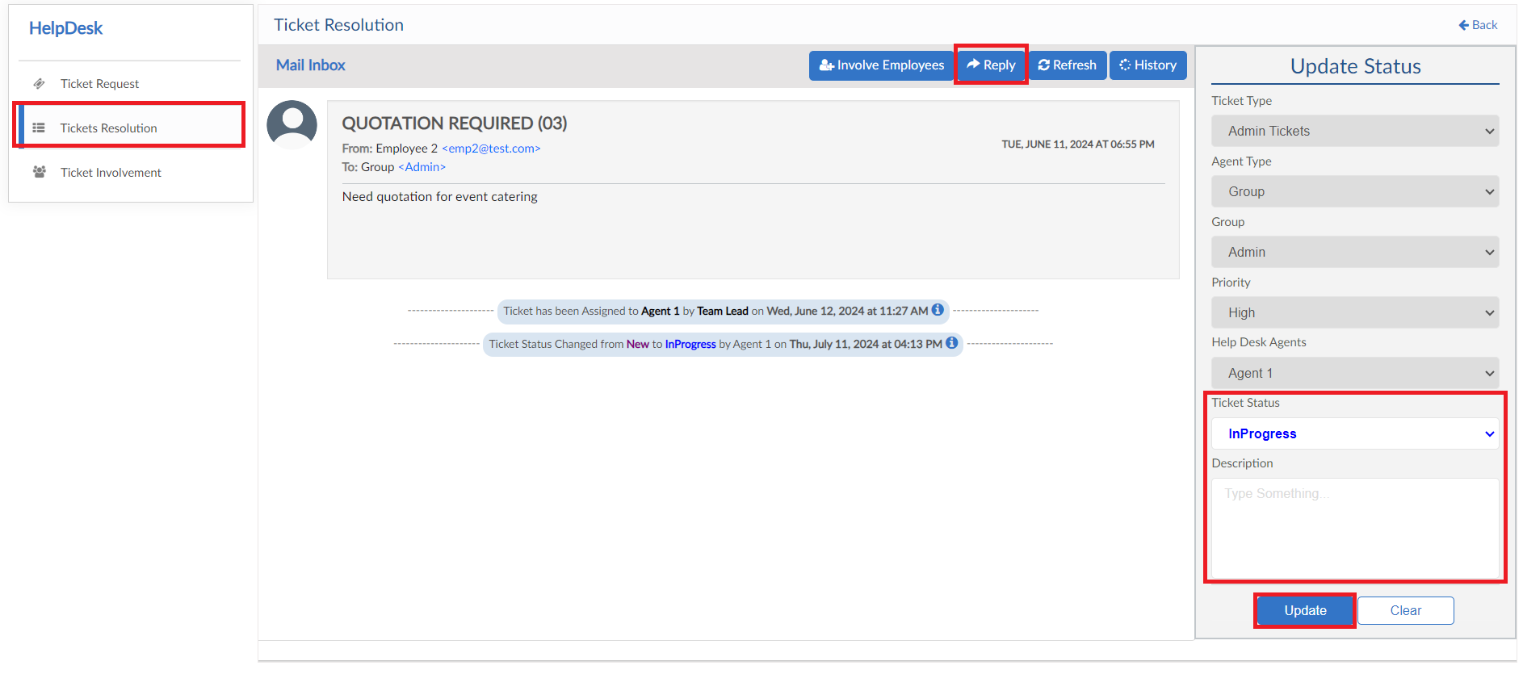
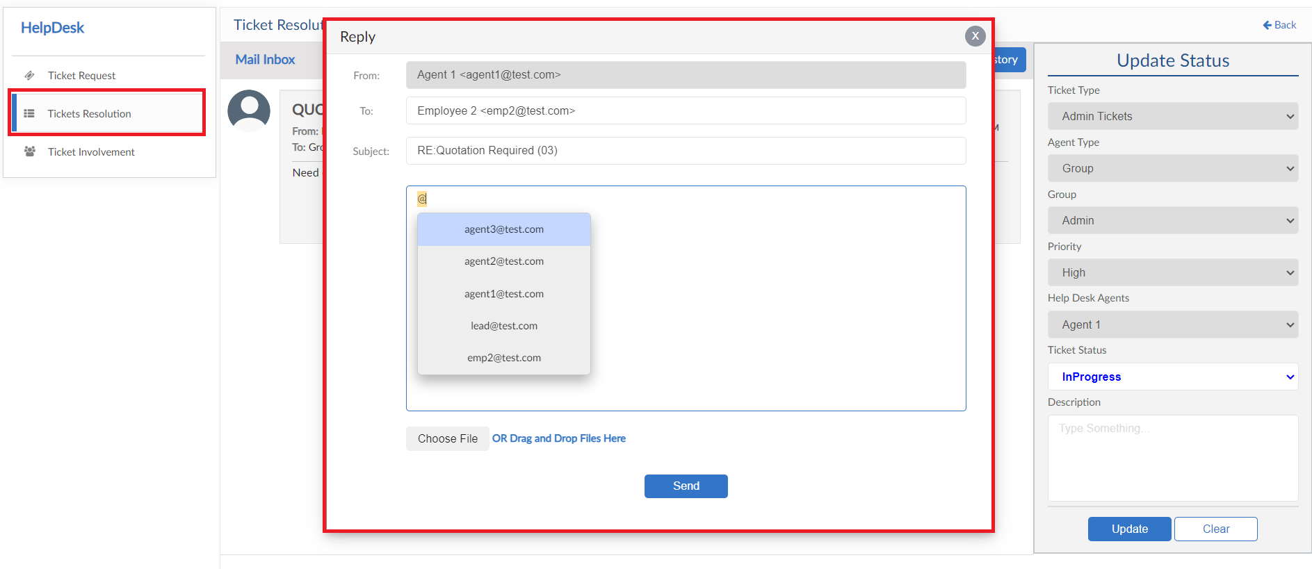
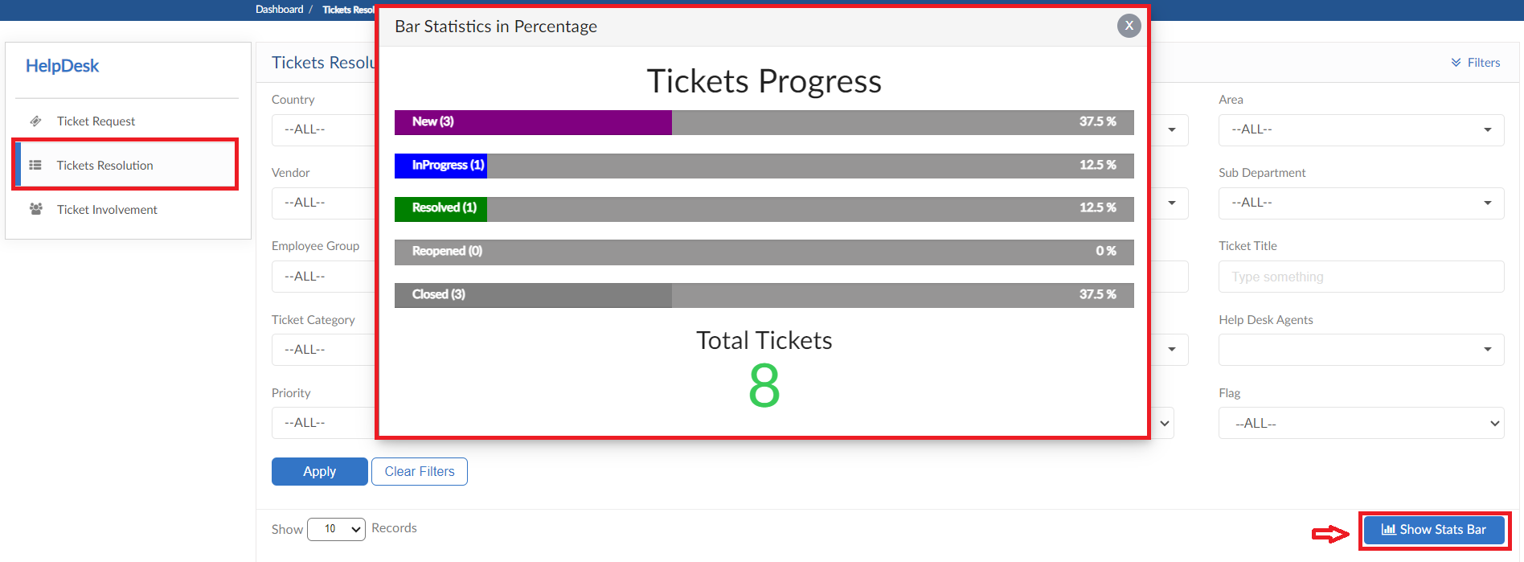

Ticket Involvement
- Agent or Requester can involve any employee in the ticket as well
- Click on Involve Employee and Select employee from dropdown and a reason to involve
- After the employee is involved, the request will be seen in this screen
- Click on action button to view the ticket and perform required action
- Ticket screen show all this history of action

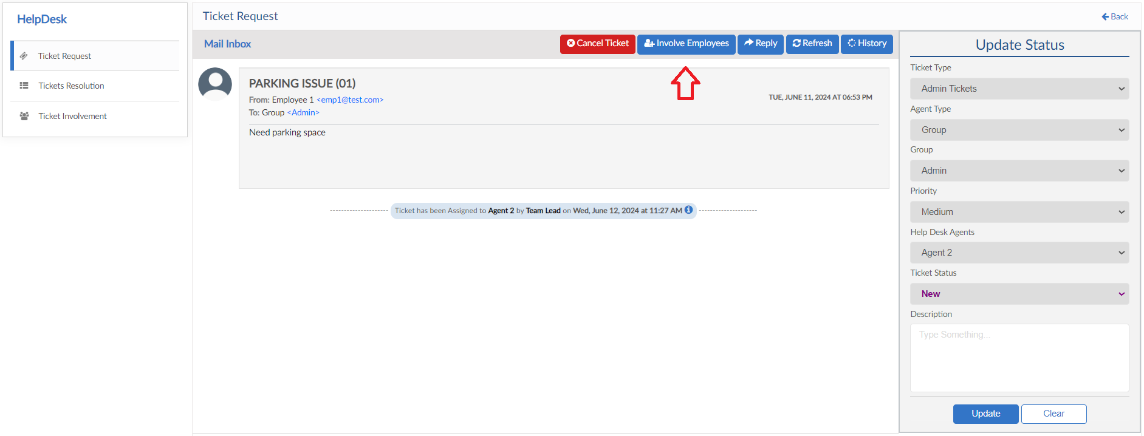
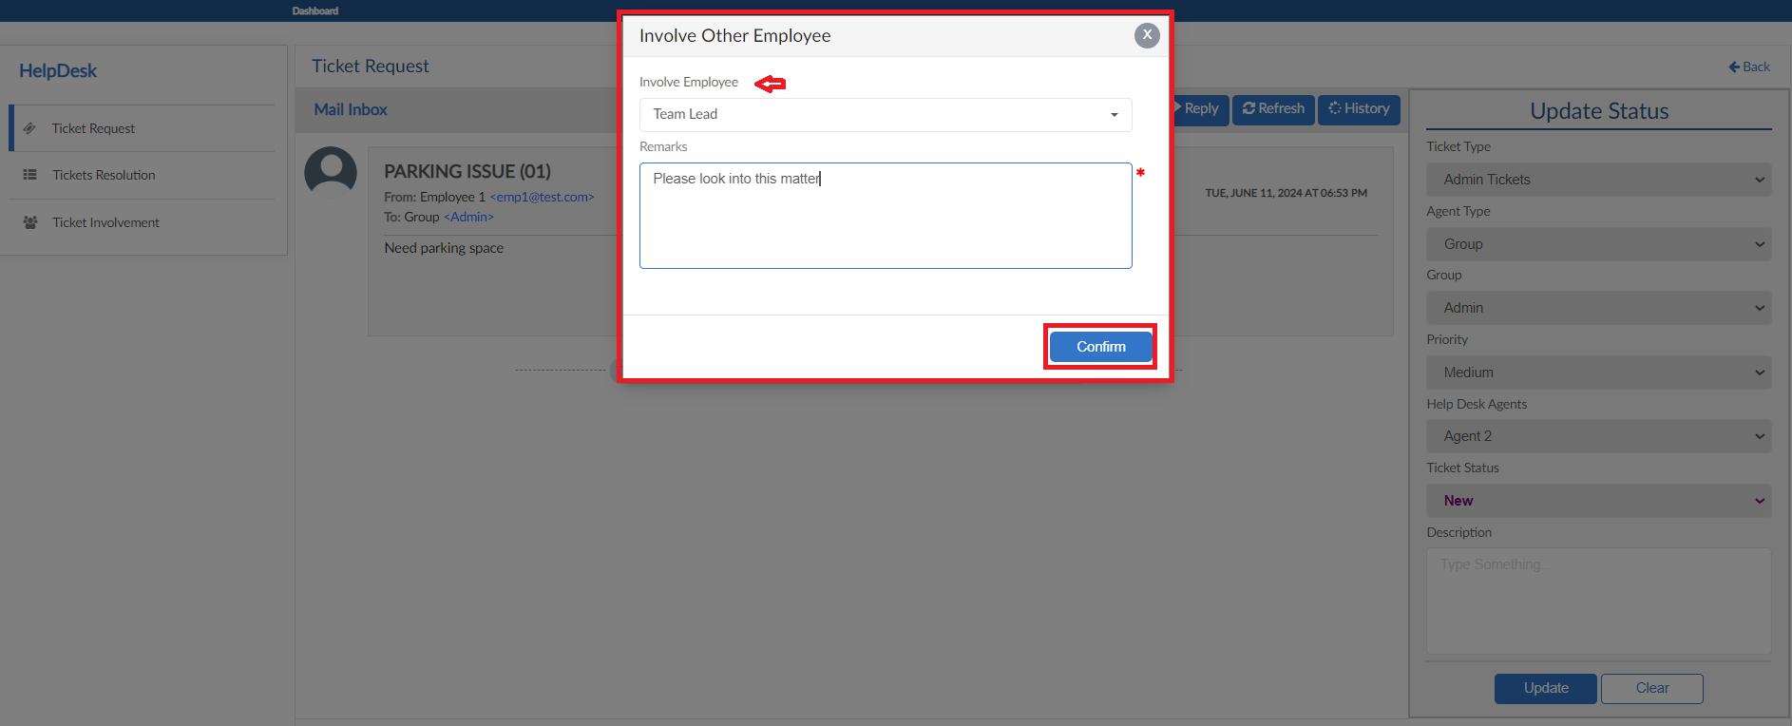
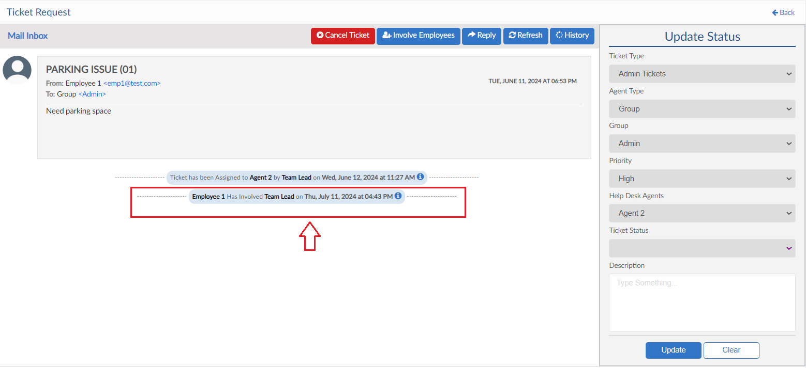

Desk Management Module

Desk Request
- To add Desk Request, click on Add New Request button
- Fill out the information (Employee, Office, Floor, Room and Dates) to see the availability of seats in that particular office
- Enter reason for request and then click on submit button

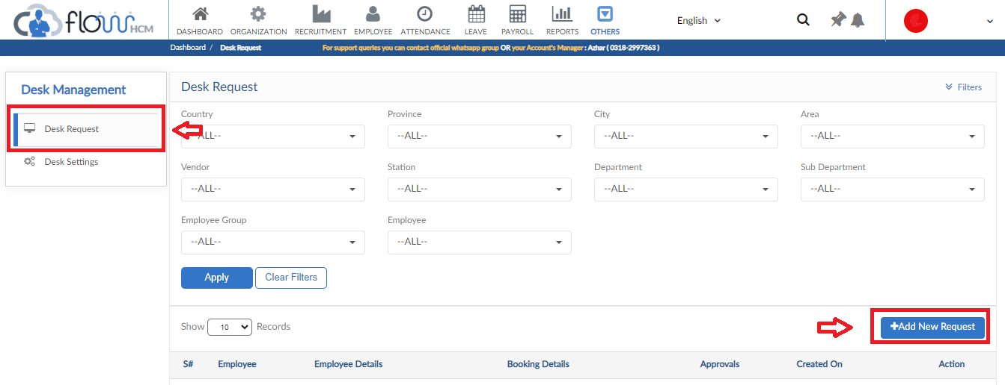
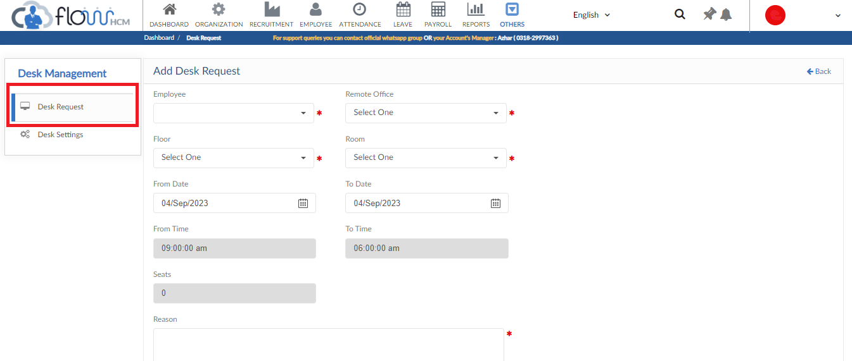

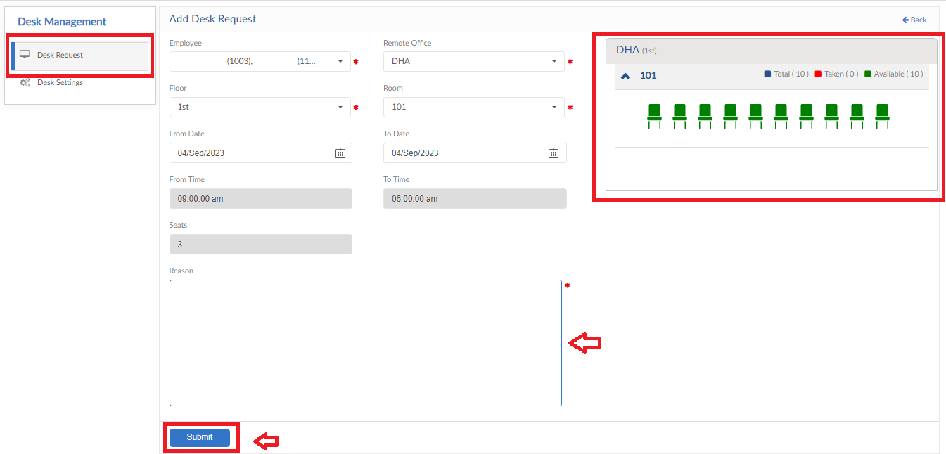

Training Module

Training Request
- To add Training Request, click on Add Training Request button
- Select the employee/employees from dropdown
- Next Select the category and Template from dropdowns
- Enter preferred Date & Time for training
- Enter reason for request and then click on submit button
